# Austrade logoChina International Fair for Trade in Services (CIFTIS)

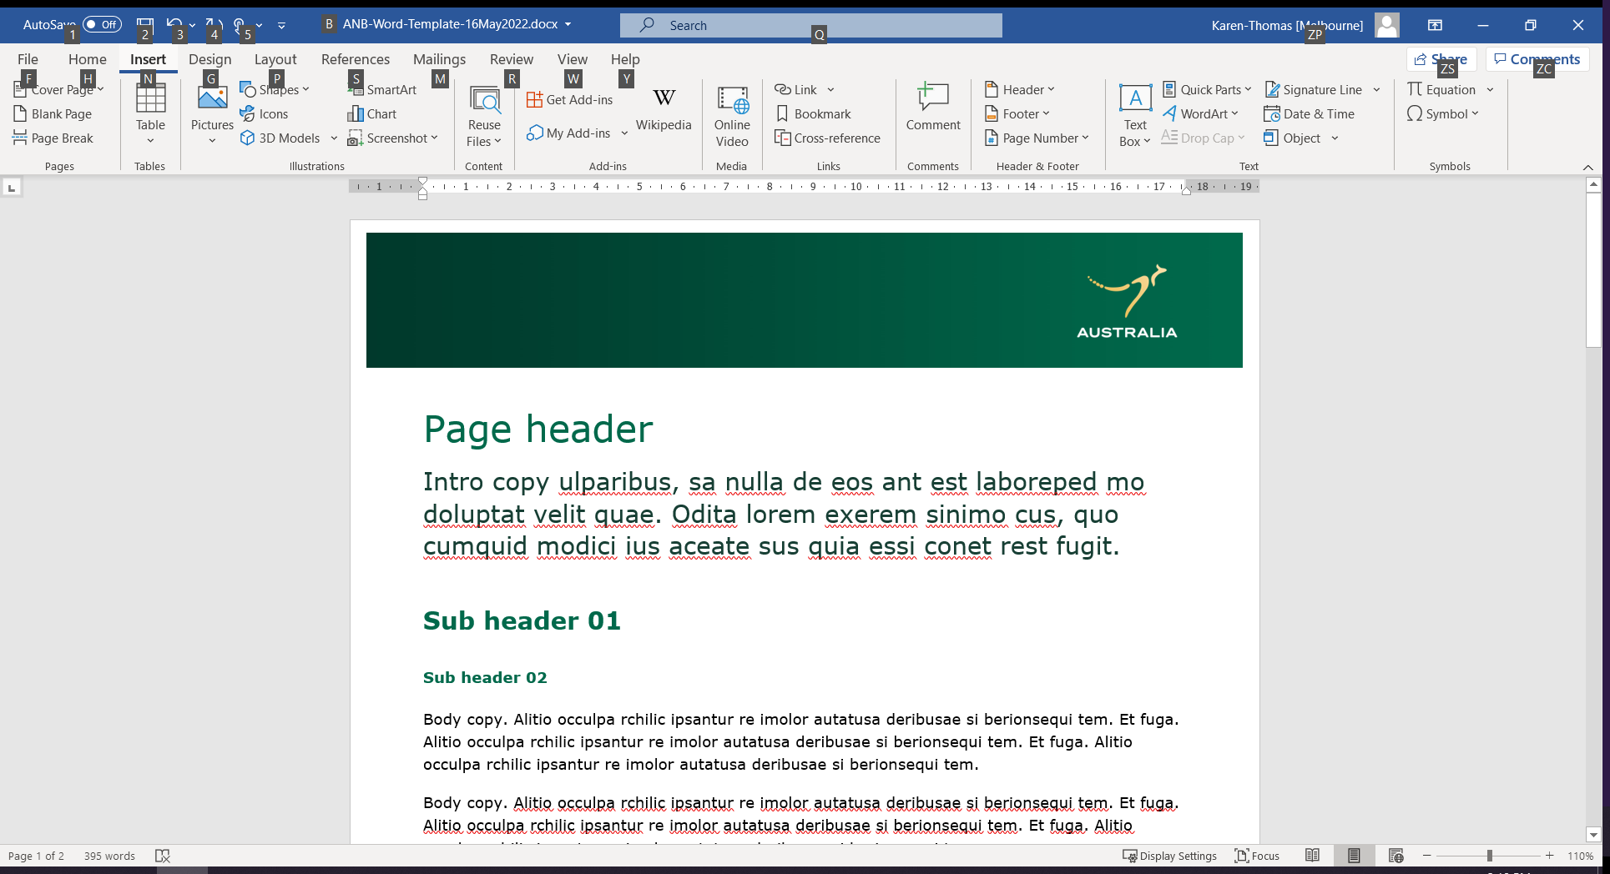

## September 2025 (Dates TBC), Beijing, China

## Participation options

### Package table

You can choose the level of participation that suits your marketing needs and budget. The cost covers all the direct cost and Austrade service fees associated with the Australian National Pavilion at CIFTIS 2025 and relevant events in the program. Delegates need to cover your own travel cost incurred. Please reach out to Austrade if you’d like to discuss additional engagement opportunities for CIFTIS.

### Platinum Partner Package, Value A$40,000

Open for:

* Australian government agencies
* Australian peak industry bodies
* Australian education providers
* Australian companies

#### Benefits:

Gain superior branding and media exposure via:

* exclusive space at prominent locations in the Australian National Pavilion to showcase your capabilities
* physical logo display at prominent locations in the Australian National Pavilion and Austrade hosted events
* multiple interview and media exposure via Chinese leading media outlets
* electronic logo and profile display at prominent locations on Austrade CIFTIS WeChat mini-program landing page
* multiple social media promotion via Austrade digital campaign for CIFTIS

Speak at Austrade hosted events prior to, during and post CIFTIS

Dedicated business matching prior to, during and post CIFTIS provided by Austrade BDMs

Limited number of Platinum Partners available.

Please express your interest online at the link below by COB Friday 28 February 2025.

EOI:[CIFTIS 2025 EOI](https://austrade.microsoftcrmportals.com/ciftis2425/)

### Gold Partner Package, Value A$20,000

Open for:

* Australian government agencies
* Australian peak industry bodies
* Australian education providers
* Australian companies

#### Benefits:

|  |
| --- |
| Gain superior branding and media exposure via   * exclusive space in the Australian National Pavilion to showcase your capabilities * physical logo display at prominent locations in the Australian National Pavilion and Austrade hosted events * interview and media exposure via Chinese leading media outlets * electronic logo and profile display at prominent locations on Austrade CIFTIS WeChat mini-program landing page * multiple social media promotion via Austrade digital campaign for CIFTIS   Speak at Austrade hosted events prior to, during and post CIFTIS  Dedicated business matching prior to, during and post CIFTIS provided by Austrade BDMs  Limited number of Gold Partners available. |

Please express your interest online at the link below by COB Friday 28 February 2025.

EOI: [CIFTIS 2025 EOI](https://austrade.microsoftcrmportals.com/ciftis2425/)

### Education Package, Value A$5,000

Open for Australian education providers.

#### Benefits

Gain branding and media exposure via:

* product and brochure displayed at group showcase area in the Australian National Pavilion
* electronic logo displayed in the Australian National Pavilion
* electronic logo and profile displayed at Austrade CIFTIS mini-program landing page
* social media promotion via Austrade digital campaign for CIFTIS

Attend Austrade hosted events prior to, during and post CIFTIS

Business matching opportunities during CIFTIS

Please express your interest online at the link below by COB Friday 28 February 2025.

EOI: [CIFTIS 2025 EOI](https://austrade.microsoftcrmportals.com/ciftis2425/)

### Agri-food & Consumer (AFC) Package A, Value A$50,000

Open for Australian sustainable agriculture, food and consumer businesses.

#### Benefits

Gain superior branding and media exposure via:

* exclusive space at prominent locations in the Australian National Pavilion to showcase your capabilities
* physical logo display at prominent locations in the Australian National Pavilion
* Austrade organised livestreaming sessions
* electronic logo and profile displayed at Austrade CIFTIS mini-program landing page
* multiple social media promotion via Austrade digital campaign for CIFTIS

Attend Austrade hosted events prior to, during and post CIFTIS

Business matching opportunities during CIFTIS

Limited space available.

Please express your interest online at the link below by COB Friday 28 February 2025.

EOI: [CIFTIS 2025 EOI](https://austrade.microsoftcrmportals.com/ciftis2425/)

### Agri-food & Consumer (AFC) Package B, Value A$25,000

Open for Australian sustainable agriculture, food and consumer businesses.

#### Benefits

Gain superior branding and media exposure via:

* exclusive space at the Australian National Pavilion to showcase your capabilities
* physical logo display in the Australian National Pavilion
* Austrade organised livestreaming sessions
* electronic logo and profile displayed at Austrade CIFTIS mini-program landing page
* multiple social media promotion via Austrade digital campaign for CIFTIS

Attend Austrade hosted events prior to, during and post CIFTIS

Business matching opportunities during CIFTIS

Limited space available.

Please express your interest online at the link below by COB Friday 28 February 2025.

EOI: [CIFTIS 2025 EOI](https://austrade.microsoftcrmportals.com/ciftis2425/)

### Agri-food & Consumer (AFC) Package C, Value A$7,000

Open for Australian sustainable agriculture, food and consumer businesses.

#### Benefits

Gain branding and media exposure via:

* display space at the Australian National Pavilion to showcase your capabilities
* physical logo display in the Australian National Pavilion
* Austrade organised livestreaming sessions
* electronic logo and profile displayed at Austrade CIFTIS mini-program landing page
* social media promotion via Austrade digital campaign for CIFTIS

Attend Austrade hosted events prior to, during and post CIFTIS

Business matching opportunities during CIFTIS

Limited space available.

Please express your interest online at the link below by COB Friday 28 February 2025.

EOI: [CIFTIS 2025 EOI](https://austrade.microsoftcrmportals.com/ciftis2425/)

### Livestreaming Package, Value A$700

Open for Australian sustainable agriculture, food and consumer businesses.

#### Benefits

Gain branding and media exposure via:

* Austrade organised livestreaming sessions
* social media promotion via Austrade digital campaign for CIFTIS

Please express your interest online at the link below by COB Friday 28 February 2025.

EOI: [[CIFTIS 2025 EOI](https://austrade.microsoftcrmportals.com/ciftis2425/)](https://austrade.microsoftcrmportals.com/ciftis2425/)

### Corporate Package, Value A$700

Open for:

* Australian companies (green economy)
* Australian companies (health services, biotech & medtech products and services)

### Benefits

Gain branding and media exposure via:

* product and brochure displayed at group showcase area in the Australian National Pavilion
* electronic logo displayed in the Australian National Pavilion
* electronic logo and profile displayed at Austrade CIFTIS mini-program landing page
* social media promotion via Austrade digital campaign for CIFTIS

Attend Austrade hosted events prior to, during and post CIFTIS

Business matching opportunities during CIFTIS

Please express your interest online at the link below by COB Friday 28 February 2025.

EOI: [[[CIFTIS 2025 EOI](https://austrade.microsoftcrmportals.com/ciftis2425/)](https://austrade.microsoftcrmportals.com/ciftis2425/)](https://austrade.microsoftcrmportals.com/ciftis2425/)

### Health services package, Value A$7,000

Open for Australian companies (health services, biotech & medtech products and services)

### Benefits

Gain branding and media exposure via:

|  |
| --- |
| * exclusive space at CIFTIS China National Convention Centre or Shougang Park organised by Austrade * product and brochure displayed at group showcase area in the Australian National Pavilion at CIFTIS China National Convention Centre or in the Australian National Pavilion (health only) at Shougang Park * electronic logo displayed in the Australian National Pavilion * electronic logo and profile displayed at Austrade CIFTIS mini-program landing page * social media promotion via Austrade digital campaign for CIFTIS |

Attend Austrade hosted events prior to, during and post CIFTIS

Business matching opportunities during CIFTIS

Please express your interest online at the link below by COB Friday 28 February 2025.

EOI: [CIFTIS 2025 EOI](https://austrade.microsoftcrmportals.com/ciftis2425/)

Please note that Austrade will not go ahead with the plan of Australian National Pavilion (health only) at Shougang Park if the registered businesses are less than 3.

## Additional information

* PAYMENT: Austrade requires payment upfront for all international events. The payment term is 30 days from invoice date and your place is not fully secured until the entire fee is paid.
* Please refer to the event [Terms & Conditions](https://www.austrade.gov.au/en/site-information/terms-of-event-participation) for further detail. Non-payment by the applied deadline will result in the forfeit of your reserved place on the event.
* The direct stand cost and Austrade service fee form part of the total package and you cannot purchase one without the other.
* You may also be eligible to claim some of your marketing and promotion costs associated with this exhibition through the Export Market Development Grant scheme. For more information visit www.austrade.gov.au/grants or call 13 28 78.

Express your interest by COB Friday 28 February 2025.

In order to provide the highest level of service to delegates, places are strictly limited. Express your interest online at [CIFTIS 2025 EOI](https://austrade.microsoftcrmportals.com/ciftis2425/) to have our country and industry specialists review your application. If your application is successful, we will send you an acceptance email with the event registration link with our standard terms and conditions and an invoice for the payment. An Event Participation Kit with all the information you need will also be sent to you once your payment is done.