

# Austrade’s Trade and Inward Investment Results 2023-24

Acknowledgement of Country

In the spirit of reconciliation, Austrade acknowledges the Traditional Custodians of country throughout Australia and their connections to land, sea, and community. We pay our respect to their Elders past and present and extend that respect to all Aboriginal and Torres Strait Islander peoples today.

Foreword

Trade and investment are the lifeblood of Australia’s economy.

Australia has a long history as a trading nation: Australia’s First Nations peoples were the nation’s first exporters with tens of thousands of years of history exchanging goods, knowledge and technology.

Greater trade and investment means more jobs, boosted productivity, resilient supply chains, improved competitiveness, and a secure national future.

Australia’s future economic prosperity depends on the success of our exporters, and on attracting foreign investment to bring in the capital, skills, and technology needed to drive growth.

Australia has a well-earned reputation as a stable and trusted partner, reflected in our strong trade and investment partnerships. Australia’s growing suite of free trade agreements, including with India, the United Kingdom and the United Arab Emirates, means businesses are able to explore and diversify into new markets.

Austrade plays a significant role in supporting Australia’s hard-working exporters, while also identifying and facilitating productive foreign direct investment into key sectors.

We have a network of experts, located in market and who speak the local languages, in more than 100 offices at home and around the world.

It is this network that gives Australian businesses the competitive edge in the global marketplace.

In the last year, Austrade has supported trade clients diversify into markets across the globe: from India to the Pacific, across Southeast Asia and beyond.

Austrade has brought in new capabilities through a diverse investment pipeline, supporting the development of key areas of the economy: from renewable energy to critical technologies.

We’re delighted and proud to present this report, showcasing Austrade’s work with exporters and foreign investors in 2023-24.

Peter Horn, General Manager, Investment

Jay Meek, General Manager, Trade

Contents

**Austrade’s year in review 3**

Trade and investment annual results**4**

**Advancing Australia’s economic prosperity** **5**

**Trade highlights 2023-246**

Top sectors and markets for Austrade-facilitated export deals**6**

Case studies**7**

**Inward investment highlights 2023-2410**

Top sectors and markets for Austrade-facilitated FDI projects**10**

Case studies**11**

**Austrade at a glance14**

Australian businesses**14**

Foreign investors **14**

## Austrade’s year in review

Austrade delivers quality trade and investment services to businesses and policy advice to government to grow Australia’s prosperity.

Our trade and investment services provide advice, connections, and support. We help our clients to achieve commercial outcomes by drawing on our commercial knowledge, international networks, relationships and connections.

International trade is important for driving Australia’s economic growth and resilience. Austrade supports Australian businesses to increase their exports across a diverse range of global markets and sectors through trade facilitation, program support and the promotion of Australia’s capabilities. In 2023–24, Austrade helped Australian businesses to secure 2,099 export deals, with an estimated initial value of $4.5 billion. This is a 50% increase on the 1,402 export deals achieved in 2022–23.

Austrade attracts productive foreign direct investment (FDI) that brings in capital, skills, and technology to deliver on Australia’s strategic priorities. In 2023-24, we facilitated $11.5 billion of investment from 159 projects. This represents the highest investment value facilitated by Austrade since 2010-11.  These projects are expected to create or safeguard over 12,000 jobs.

#### Delivering for Australia

In 2023-24, Austrade delivered $4.5 billion in investment value from 63 FDI projects to support **Australia’s net zero transformation**. These projects will contribute to lowering emissions across our economy, help transform our energy systems and deliver on the Australian Government’s renewable energy superpower ambitions. They will help create or safeguard over 8,700 jobs.

FDI is critical to **strengthening Australia’s economic security and resilience**. In 2023-24, Austrade supported 75 FDI projects valued at $6.9 billion that contribute to this goal. These projects bring in new critical technologies, strengthen our manufacturing capabilities and develop critical minerals supply chains. They will help create or safeguard close to 3,300 jobs.  By attracting and facilitating these projects Austrade is helping build a stronger, more diversified and more resilient Australian economy in a changing global economic and strategic landscape.

In 2023–24, Austrade continued its focus on supporting Australian businesses to access and diversify their exports in line with Australia’s strategic interests. Austrade supported greater **diversification** of exports into the rapidly expanding economies in Southeast Asia and India, and supported exporters to access the benefits of Australia’s Free Trade Agreements and capture high-growth opportunities.

Austrade supported 59 exporters to achieve almost $144 million in export sales in the **Green Economy**, covering a broad range of areas including renewable energy, low-carbon transport, sustainable mining, and clean technologies.

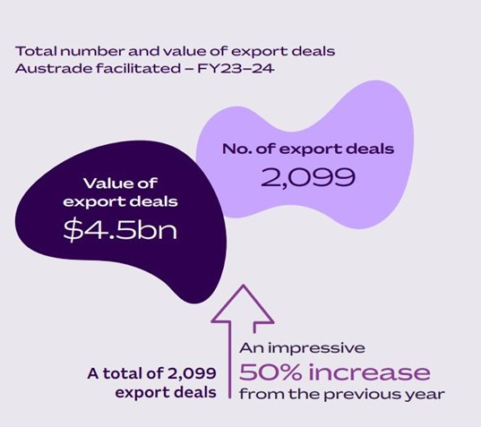

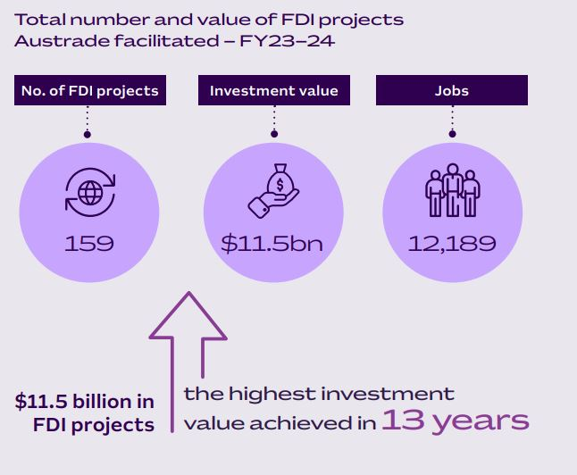

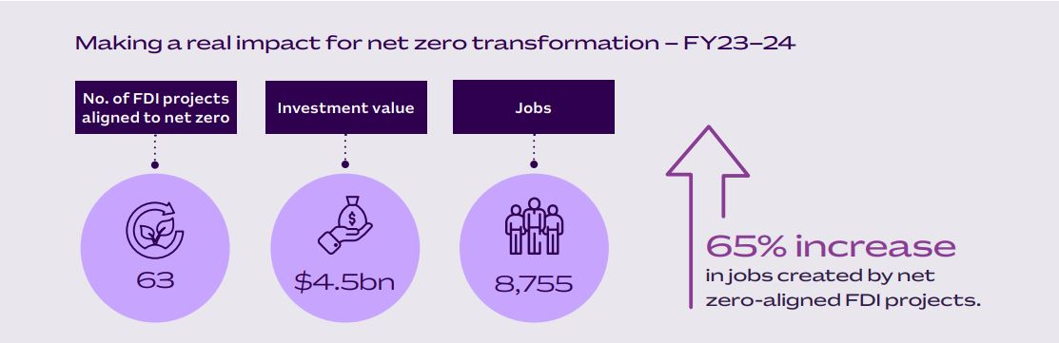

## Advancing Australia’s economic prosperity

Austrade supports Australian businesses to expand their exports into international markets to capture new growth opportunities. Australian exporters make a significant contribution to our economic growth. Economic impacts of Exports1

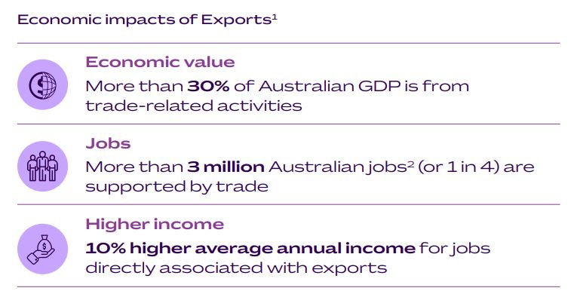

1.Based on analysis of 2021-22 data and ‘input-output’ (IO) modelling conducted by the Department of Foreign Affairs and Trade (DFAT) drawing on publicly available input-output tables and labour force data from the Australian Bureau of Statistics. 2. Full-time equivalent jobs.

Austrade works with foreign companies to identify, attract and facilitate investment projects that deliver productive FDI. ProductiveFDI helps Australia create jobs, boost productivity, improve competitiveness, and secure our future prosperity.

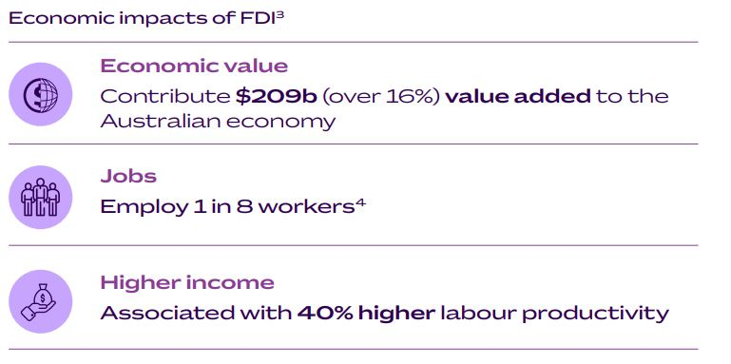

3. Based on analysis of 11,600 companies with more than 10% foreign-ownership after investment, using 2020–21 data from the Australian Bureau of Statistics’ Business Longitudinal Analysis Data Environment (BLADE). Partnerships, trusts, ABNs for individuals, and businesses without an ABN were excluded from the study; 4. Full-time equivalent jobs.

## Trade highlights 2023-24

### Top sectors and markets for Austrade-facilitated export deals

| **Top 5 Markets\*** | | |
| --- | --- | --- |
| **Market** | **Export deals** | **Value** |
| India | 189 | A$428m |
| China | 183 | A$515m |
| USA | 135 | A$433m |
| Japan | 120 | A$258m |
| Thailand | 115 | A$177m |

\**by number of export deals facilitated by Austrade*

| **Regional breakdown** | | |
| --- | --- | --- |
| **Region** | **Number of export deals Austrade facilitated** | **Value** |
| Americas | 331 | $806m |
| Middle East and Africa | 290 | $203m |
| Europe | 117 | $124m |
| South Asia | 226 | $589m |
| Northeast Asia | 220 | $340m |
| Mainland China, Hong Kong, and Taiwan | 334 | $690m |
| Southeast Asia | 529 | $1.6bn |
| Pacific | 52 | $128m |

| **Sector breakdown by no. of export deals** | | |
| --- | --- | --- |
| **Sector** | **Number of export deals Austrade facilitated** | **Value** |
| Education | 788 | $731m |
| Agribusiness & Food | 705 | $978m |
| Defence, Advanced Manufacturing & Space | 146 | $782m |
| Technology | 116 | $110m |
| Resources & Energy | 99 | $478m |

## Case studies

#### A closer look at how Austrade has helped Aussie businesses go global.

### Food and beverage

#### NAAKPA

Austrade supported the Northern Australia Aboriginal Kakadu Plum Alliance Cooperative Limited (NAAKPA) to expand into international markets such as Japan.

NAAKPA is a First Nation business that harvests 40% of the Kakadu plum in Australia. It transforms the harvests into food ingredients that are unique to Australia. The business is committed to providing work and income to several hundred Indigenous families in the most remote areas of Northern Australia.

**Austrade’s impact**

With Austrade’s facilitation, NAAKPA successfully secured an export deal with the Japanese company Horizon Farms at the Fine Food exhibition Australia in Sydney.

*NAAKPA’s CEO Paul Saeki wrote* “***The relationship (with Horizon Farms) is a direct result of the Austrade meetings you helped coordinate at Fine Foods Australia last September***.”

Austrade also supported NAAKPA with an Action Plan that focused on getting the client ready for export, introducing multiple Austrade teams and external stakeholders.

Austrade will continue advising and supporting NAAKPA to grow faster and further into other selected markets, paving the way for other First Nations exporters to follow suit.

### Health

#### Nucleus Network

Nucleus Network is Australia’s largest Phase I clinical trial provider. The company employs 600 staff globally, with clinics in Brisbane, Melbourne, Geelong, and Minneapolis in the US. It is the world’s only multi-site, multi-country, Phase 1 clinical trial specialist, operating in Australia and the US.

**Austrade’s impact**

Austrade has been supporting Nucleus Network to grow internationally for more than 10 years. Over this time, Austrade has provided business-matching services, introductory meetings, and market insights. Austrade is also working with the company to explore new two-way trade and investment opportunities.

In November 2023, Austrade invited Nucleus Network to be a keynote speaker at a forum showcasing Australian clinical trial capabilities to an international audience. Austrade has also invited the company to participate at global biotech events including the 2023 and 2024 Team Australia presence at [BIO KOREA](https://www.biokorea.org/index.asp). Nucleus Network has built their profile and gained new international partners from these events.

‘***Thanks to Austrade, we continue to build our profile in international markets, biotech industries, health sectors and conferences***,’ *says CEO of Nucleus Network, Teena Pisarev.*

### Education

#### Deakin University / University of Wollongong

Deakin University and the University of Wollongong have become the first international universities to establish branch campuses in India’s GIFT City in 2024.

Championed by the Australian Prime Minister Albanese and India’s Prime Minister Modi, the universities will provide world-class courses to India’s burgeoning middle class under their New Education Policy.

The offshore campuses offer several master's programs with Bachelor programs to come. They allow Indian students to access quality Australian education. All admission criteria and course requirements match those set in Australia and the academic standards directly align with Australia’s national accreditation body.

**Austrade’s impact**

Austrade has been a major supporter of both universities in their respective journeys. Austrade helped the clients to assess the market opportunity, introduced them to local government regulators and business partners, and provided the necessary cultural advice.

### Advanced tech

#### MyVenue

A 2023 Australian Export Awards winner, MyVenue provides built-for-purpose next-generation point-of-sale (POS) software for iconic venues worldwide.

MyVenue’s deployments have grown 250% in the past 12 months. It also continues to grow its key export markets, including the US, Canada, and the UK.

Headquartered in Adelaide, MyVenue employs 50 staff globally. The award-winning company has made it to the [Major League](https://www.mlb.com/) Baseball under 3 years. Its POS solution processes transactions for the Chicago Cubs, Chicago White Sox, LA Angels, and New York Yankees.

**Austrade’s impact**

Austrade has supported MyVenue with its growth in the US market. Austrade profiled the company as an Australian innovation success story during the Prime Minister Anthony Albanese’s visit to the US, hosted by the US President Joe Biden. MyVenue is now working with Austrade to grow its profile in the UK and European markets.

‘These are powerful opportunities for a growing Aussie company,’ says Tim Stollznow. ‘The right connections are an important foundation to global success, and Austrade has got it right. We are proud to have the Austrade engine supporting our international growth.’

### Infrastructure

#### Hall Contracting

Hall Contracting has been delivering dredging and land reclamation projects across Southeast Asia and the Pacific Islands since 1999. The company provides climate change adaptation and sustainable marine infrastructure solutions. It also upskills the local workforce, provides certifications and creates employment opportunities.

This year, the World Bank Group awarded Hall Contracting a $19 million contract to develop the Funafuti Wharf in Tuvalu. Hall Contracting also delivered new facilities on Tuvalu’s Nui atoll which became operational in February 2024, 150 days ahead of schedule. The project employed 12 Tuvaluans and 8 Fijians.

Hall Contracting also delivered stage one of the Tuvalu Coastal Adaptation Project in 2024. Funded by the Green Climate Fund and Tuvalu and Australian Governments, it is part of a plan to expand the size of the liveable area of Funafuti and raise the ground level to provide more resilience in response to predicted sea level rise, storms and extreme weather events.

**Austrade’s impact**

Austrade's in-market support included facilitating visits to Tuvalu and identifying business opportunities. Austrade’s continuous support and commercial insights also helped Hall Contracting bid for contracts in the Pacific Islands region and gain further success.

### Defence and Advanced Manufacturing

#### The Whiskey Project Group

Australian specialist and tactical watercraft manufacturer, [The Whiskey Project Group (TWPG)](https://www.thewhiskeyproject.com.au/) has designed and built a new generation advanced tactical multi-mission watercraft.

TWPG has already successfully delivered two 11-metre Whiskey Bravo – Multi Mission Reconnaissance Craft (MMRC) to the United States Marine Corps (USMC) at the Marine Corps Base Camp Pendleton, Southern California, in February 2024.

The landmark export contract with the US Marines saw an exceptionally fast delivery and is one of the first industry-led examples of AUKUS Pillar II technology collaboration and sharing.

**Austrade’s impact**

Former Australian Navy Clearance Diver and founder Darren Schuback credits Austrade with helping promote his designs and introducing his business to the US Military. ‘Austrade’s US team have supported TWPG to build one-on-one relationships and create opportunities for innovation-sharing with Australia’s allies,’ he says.

Austrade and the Australian Embassy in Washington, including Australia’s Ambassador to the United States of America, Dr Kevin Rudd AC, also facilitated a range of engagements with senior US military and government officials.

***‘We were grateful to have the support of Austrade behind us when we announced our export contract with the US Military at the Australian Embassy in October 2023.  Having the full backing of the Austrade team and the Ambassador not only enabled us to meet with US government officials and industry stakeholders, but crucially, also supported our conversations back into the Australian Government and Defence.****’  CEO* Darren Schuback said.

## Investment highlights 2023-24

### Top sectors and markets for Austrade-facilitated FDI projects (MAP)

\**by estimated investment value*

| **Top 5 markets\*** | | | |
| --- | --- | --- | --- |
| **Market** | **Inv. value** | **FDI Projects** | **Total Jobs** |
| United States of America | $6.6bn | 43 | 1,740 |
| Spain | $1.1bn | 7 | 2,602 |
| France | $599m | 4 | 473 |
| Germany | $480m | 6 | 497 |
| United Arab Emirates | $413m | 1 | 1,192 |

|  |  |  |  |
| --- | --- | --- | --- |
| **Top regions by investment value** | | | |
| **Region** | **Investment value** | **FDI projects** | **Jobs** |
| Americas | $7bn | 53 | 2,613 |
| Europe | $3bn | 46 | 6,284 |
| South Asia | $71m | 5 | 270 |
| Northeast Asia | $306m | 20 | 424 |
| Mainland China, Hong Kong & Taiwan | $386m | 18 | 674 |
| Southeast Asia | $219m | 16 | 732 |
| Middle East & Africa | $414m | 1 | 1,192 |

|  |  |  |  |
| --- | --- | --- | --- |
| **Top sectors by investment value** | | | |
| **Sector** | **Investment value** | **FDI projects** | **Jobs** |
| Technology | $5.6bn | 40 | 1,684 |
| Energy & Resources | $2.9bn | 39 | 3,505 |
| Circular Economy & Infrastructure | $1.2bn | 18 | 3,941 |
| Agri-Business & Food | $1bn | 22 | 1,294 |
| Health | $332m | 25 | 381 |

| **Top 5 net zero-aligned subsectors by investment value** | | |
| --- | --- | --- |
| **Sector** | **Investment value** | **FDI projects** |
| Renewables (incl. solar, wind and other renewables) | $1.9bn | 13 |
| Transmission | $533m | 1 |
| Recycling & Waste to Energy | $445m | 4 |
| Hydrogen | $415m | 10 |
| Critical Minerals & Processing | $255m | 4 |

## 

## Case studies

#### A closer look at what foreign companies have to say about Austrade’s services.

### Renewable energy/First Nations

#### ACEN

The First Nations Yindjibarndi people have partnered with Filipino-listed renewables company ACEN to develop and operate clean energy projects in Western Australia’s Pilbara region.

The partnership is one of Australia’s largest renewable energy initiatives led by First Nations peoples. The joint venture saw ACEN and the Yindjibarndi Aboriginal Corporation form the Yindjibarndi Energy Corporation (YEC). This secures equity shares for Traditional Owners of between 25% to 50% in all completed projects. The deal also establishes preferred contracting for Yindjibarndi-owned businesses, and training and employment opportunities for their peoples.

**Austrade’s impact**

*Patrice Clausse, ACEN International CEO, said: “****Austrade is helping us keep up to date with developments in Australia’s growing renewable energy sector, and sharing information on investment opportunities. They are also pivotal in helping us connect with government representatives at federal and state levels.’***

Read more [here](https://international.austrade.gov.au/en/news-and-analysis/success-stories/yindjibarndi-people-partner-with-acen-to-bring-clean-energy-to-western-australia).

### Renewable hydrogen

#### Central Queensland Hydrogen (CQ-H2) consortium

A consortium of Japanese, Singaporean and Australian companies is investing $117 million to help develop one of Australia’s largest green hydrogen projects.

Members of the consortium include Japan’s Iwatani Corporation and Marubeni Corporation, Singapore’s Keppel and Australia’s Stanwell Corporation, a Queensland state-owned energy provider. The consortium’s investment is funding a Front-End Engineering Design (FEED) study for the Central Queensland Hydrogen (CQ-H2) Project, which will involve the development of a global-scale hydrogen production facility, a hydrogen gas pipeline, and a liquefaction facility, as well as a supply of hydrogen to an ammonia production facility.

The CQ-H2 Project aims to generate 200 tonnes of green hydrogen per day by 2029, potentially ramping up to 800 tonnes per day by 2031. In the initial phase, green hydrogen is proposed to be supplied to an ammonia production facility in Gladstone, and in later phases, the green hydrogen will be liquefied and exported to Japan.

At its peak, the project could support more than 3,100 new jobs and deliver $14.5 billion in hydrogen exports over its 30-year life.

**Austrade’s impact**

Austrade has been providing support to project investors since 2019, helping consortium members to identify Australian joint venture partners and connecting them to government agencies. Austrade also helped identify important offtake opportunities to ensure future investment returns, providing advice on policies, incentives, and government funding support.

Read more [here](https://international.austrade.gov.au/en/news-and-analysis/success-stories/global-consortium-invests-a117m-dollars-in-australian-green-hydrogen-project).

### Transmission

#### Grupo Cobra

Spanish company Grupo Cobra formed a consortium with Acciona and Australia’s Endeavour Energy to deliver transmission infrastructure for the first Renewable Energy Zone (REZ) in New South Wales.

The consortium will build and operate the transmission network for the 20,000-square kilometre Central-West Orana Renewable Energy Zone for the next 35 years. The project will enable solar and wind farm generators and energy storage entities to connect to the Australian electricity grid. The network capacity could reach up to 6 GW by 2038.

José María Castillo, CEO of Grupo COBRA said: ‘We are keen to contribute to the development and construction of electricity infrastructure such as the REZ to help address the expansion of reliable and clean energy in the state.’

**Austrade’s impact**

Austrade has been working with Grupo Cobra for more than a decade. Austrade provided market insights on Australia’s electricity transmission network to help identify investment opportunities. Austrade also made introductions to key stakeholders such as the La Camara, the Spanish-Australian Chamber of Commerce.

[Read more here](https://international.austrade.gov.au/en/news-and-analysis/success-stories/grupo-cobra-in-consortium-to-supply-new-transmission-network).

### Critical technologies - cloud computing, AI & cyber security

#### Microsoft

Microsoft is investing 5 billion over two years to expand its hyperscale cloud computing and AI infrastructure in Australia. Microsoft’s investment will grow its computing capacity by around 250%, enabling the company to meet Australia’s growing demand for cloud computing services. Microsoft will utilise low-carbon materials and renewable energy to build its new data centres.

*Brad Smith, Microsoft Vice Chair and President, noted* ***“This is our largest investment in Microsoft’s 40-year history in Australia and a testament to our commitment to the country’s growth and prosperity in the AI era****”.*

As part of its investment, Microsoft will also extend its global skills program to offer training to over 300,000 Australians in AI and cloud technologies.

Microsoft and the Australian Signals Directorate also announced the Microsoft-Australian Signals Directorate Cyber Shield (MACS) initiative, focused on improving protection from cyber threats through next-generation cyber security solutions.

**Austrade’s impact**

John Galligan, General Manager at Microsoft Australia & New Zealand said ‘Austrade plays such a valuable role in spotting new opportunities to drive mutual benefit for Microsoft and Australia. This project benefited from our ability to build a connected engagement across a range of government and industry stakeholders in Australia, policy makers, and the Australian Embassy in Washington DC.’

Read more [here](https://international.austrade.gov.au/en/news-and-analysis/success-stories/microsofts-a5billion-investment-to-boost-australias-digital-capability).

### Critical technologies – Quantum technologies

#### Oxford Instruments

UK-based Oxford Instruments have established a new Australia and New Zealand hub in Australia. The company will develop R&D with local academic communities to unlock solutions for microscopy and analysis techniques, cryogenic systems for quantum computing and semiconductor fabrication equipment.

Oxford Instruments is also at the commercialisation end of quantum technology, which will be essential to achieving net zero.

***‘It’s very exciting to bring Oxford Instruments’ experience to Australia and see the culture here shifting towards producing strong commercial and applied research that can help us solve problems at scale,***’ said Jonathan Byron, President of East and Southeast Asia, Oxford Instruments.

**Austrade’s impact**

***‘The support*** ***we’ve had from Austrade has been over and above my expectations. It is extended from introductions to detailed market sector overviews, to practical and logistical issues like setting up a business in Australia,’*** said Jonathan Bryon.

Read more [here](https://international.austrade.gov.au/en/news-and-analysis/success-stories/oxford-instruments-microanalysis-technology-helping-unlock-solutions-to-macro-challenges).

### Clean technology manufacturing

#### ESS Inc

US-based ESS Inc. (ESS) and Australia’s Energy Storage Industries (ESI) have formed a partnership to assemble and distribute large-scale iron flow batteries across the Oceania region.

Under an agreement signed in 2022, ESS will initially supply Energy Warehouse systems manufactured in the United States to ESI. Beginning in 2025, ESI will begin conducting final assembly of Energy Warehouse systems in Queensland, with core technology supplied by ESS, for distribution across Australia, New Zealand and Oceania.

‘***We could have sought to grow our business in any number of places – but Australia offered the right combination of regulatory imperative, business-friendly environment, and appealing partnership opportunities. We are confident of a long-term future in Australia***,’ *said Eric Dresselhuys, CEO of ESS.*

**Austrade’s impact**

Austrade has been supporting ESS since 2018. Austrade has provided information on Australia’s energy industry, investment incentives and tender opportunities. Key introductions were made to connect ESS with state government agencies and major Australian companies.

Read more [here](https://international.austrade.gov.au/en/news-and-analysis/success-stories/ess-partners-with-australian-company-esi-to-build-iron-flow-batteries-in-queensland).

Austrade at a glance

We are the Australian Trade and Investment Commission – or Austrade – and we are responsible for promoting Australian trade, investment, and education to the world, as well as developing tourism policy for the country.

Our purpose is to deliver quality trade and investment services to businesses, and policy advice to government, to grow Australia’s prosperity.

Our trade and investment services are centred around advice, connections, and support. We support our clients to achieve commercial outcomes through drawing on our commercial knowledge, international networks, relationships and connections with international customers and decision makers.

### Australian businesses

Austrade is here to help Australian businesses go global.

Whether you are a fintech startup, an agricultural producer, or a manufacturer, we have the expertise, the contacts, and the market intelligence to help you grow your business. Every year, we connect thousands of businesses to opportunities and partners around the world, with in-market and local language assistance.

Contact us at austrade.gov.au or call 13 28 78

### Foreign investors

Looking to invest in Australia? We are here to help.

We support foreign investors to establish and expand operations in Australia. Our experts in Australia and around the world can help you through every stage of your investment journey. We offer the latest industry insights, connections with key stakeholders and decisionmakers, and virtual or physical site visits to Australia.

Thousands of foreign businesses have worked with us to tap into the Australian market – and you can too.

Contact us at austrade.gov.au or call 13 28 78

Disclaimer

This report has been prepared by the Commonwealth of Australia represented by the Australian Trade and Investment Commission (Austrade). The report is a general overview and is not intended to provide exhaustive coverage of the topic. The information is made available on the understanding that the Commonwealth of Australia is not providing professional advice.

While care has been taken to ensure the information in this report is accurate, the Commonwealth does not accept any liability for any loss arising from reliance on the information, or from any error or omission, in the report.

Any person relying on this information does so at their own risk. The Commonwealth recommends the person exercise their own skill and care, including obtaining professional advice, in relation to their use of the information for their purposes. The Commonwealth does not endorse any company or activity referred to in the report, and does not accept responsibility for any losses suffered in connection with any company or its activities.

Copyright © Commonwealth of Australia 2024 The material in this document is licensed under a Creative Commons Attribution – 4.0 International licence, with the exception of:

• the Commonwealth Coat of Arms

• the Australian Trade and Investment Commission’s logo

• any third party material

• any material protected by a trade mark

• any images and photographs.

More information on this CC BY licence is set out at the creative commons website: ttps://creativecommons.org/licenses/by/4.0/legalcode.

Attribution

Before reusing any part of this document, including reproduction, public display, public performance, distribution, dissemination, communication, or importation, you must comply with the Attribution requirements under the CC BY licence. Enquiries about this licence and any use of this document can be sent to: advisory@austrade.gov.au