
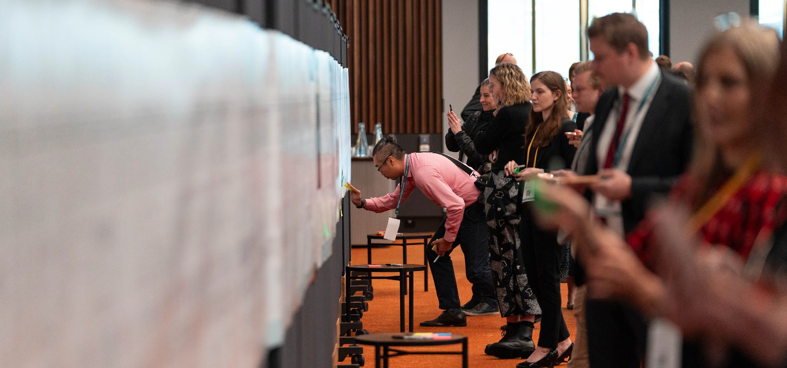
The inaugural Simplified Trade System (STS) Summit was held in Melbourne on 26 June 2023. The STS Summit hosted over 300 senior industry leaders,
Simplified Trade System Implementation Taskforce
STS Summit Outcomes
government executives, international guests, members of the diplomatic corps, academics, and members of the community. The program included industry and government panel discussions, networking opportunities and a range of breakout sessions designed to facilitate conversations on STS reforms and cross-border trade more broadly. The STS Summit was an opportunity for business and government to discuss opportunities and challenges to reform Australia’s cross-border trade environment.

Key insights
Insights focussed on the themes of opportunity, progress and delivery. Support from senior government ministers and officials was clear. Prominent business leaders emphasised the productivity potential of STS reforms and they, along with industry attendees, restated their enthusiasm in playing a part in the future direction of trade.
The importance of working with our partners and drawing on industry best practices was highlighted, as were opportunities to better use data and information to increase trust and efficiency. The need to rethink our regulatory foundations to ensure the delivery of fit for purpose policy will also help to avoid the risk of simply placing out of date, duplicative rules on a new technology platform.


The Australian Government’s vision for creating a simpler, more effective, inclusive and sustainable cross-border trade environment for Australia was well supported. The idea of replacing existing fragmented and duplicative processes resonated strongly with delegates as did the opportunity to provide feedback as part of the public consultation process.

Opening keynote addresses

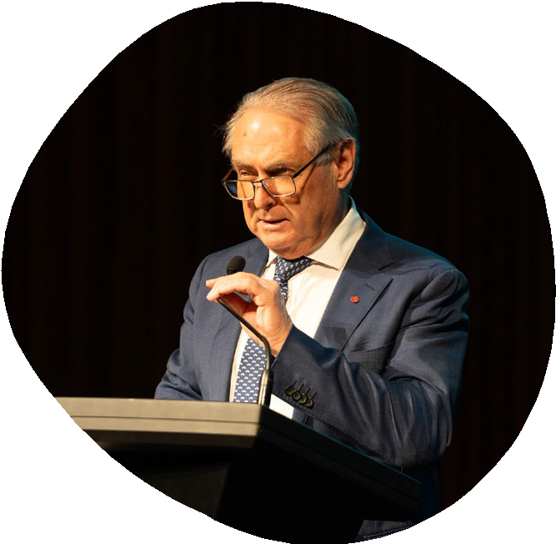
The STS Summit’s first ministerial address was delivered by Senator the Hon. Don Farrell Minister for Trade and Tourism and Special Minister of State. The Minister addressed the challenges faced by Australia's trade environment, including the current inefficiencies and high compliance costs associated with Australia's border
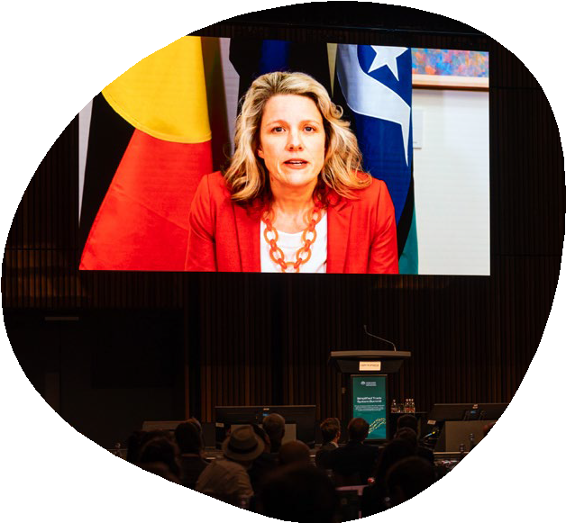
processes, and the need to enhance our competitiveness. He introduced the Simplified Trade System agenda as a whole-of-government approach to simplify rules, streamline processes, and make digital systems easier to use. The Minister also reinforced the range of Government priorities in place to diversify trade and boost supply chain resilience, including the Trade Diversification Plan, Trade 2040, the National Freight and Supply Chain Strategy, the Indo-Pacific Economic Framework, and the National Biosecurity Strategy.

The Hon. Clare O’Neil MP Minister for Home Affairs highlighted the importance of Australia’s cross-border trade system and the Simplified Trade System reforms. The Minister highlighted the significant volume of traded imports and the role of customs officials in collecting revenue and preventing social harms. She acknowledged the Australian Border Force (ABF)'s support for the STS agenda through initiatives related to the regulatory
approach, supply chain integrity, advanced cargo screening, and operational partnerships. She expressed her goal
of advancing a prosperous and secure Australia through trade modernisation.

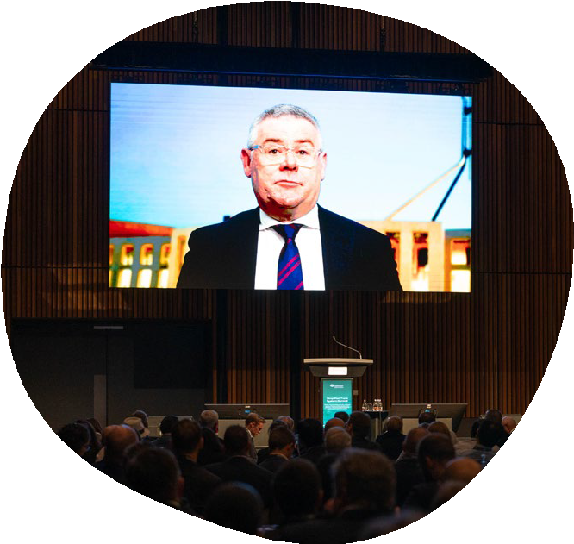
Senator the Hon. Murray Watt Minister for Agriculture, Fisheries and Forestry that international trade is central to the economic future of our agriculture, fishery and forestry sectors. He covered Australia's leadership in
adopting electronic certification (e-cert) and highlighted the successful implementation of a system-to-system e-cert exchange with the EU. The Minister raised how Government is investing in digital services to enhance agricultural export capabilities and streamline regulations and concluded that Australia is continuing to work hard on the EU Free Trade Agreement and to restore trade ties with China.

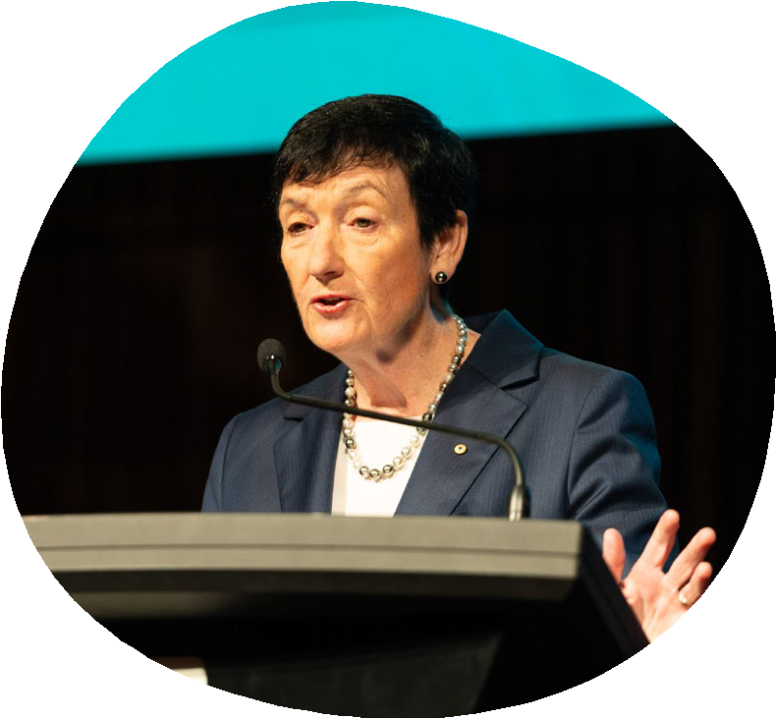
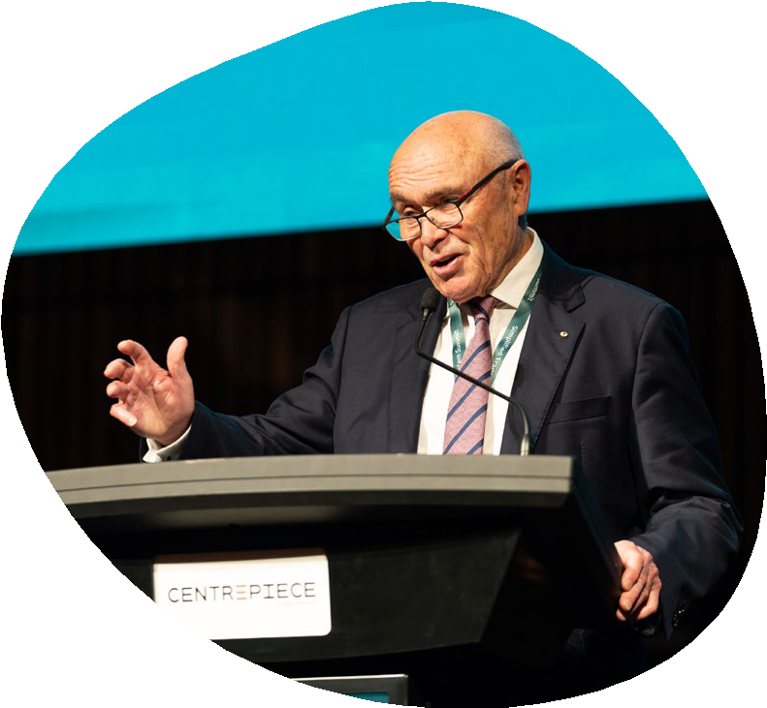
Paul Little, Chair of the STS Industry Advisory Council (IAC) commended Minister Farrell on his leadership and support for the STS reform agenda and highlighted their shared focus on the importance of engaging with customers, importers, exporters, and stakeholders on STS reforms. He discussed the role of the IAC in gathering insights and providing feedback to the Minister and the STS Taskforce. Mr Little mentioned visits to international locations like Singapore's PSA port, the Western Sydney Airport and Sydney's container examination facility to learn best practices and understand current issues.

Jennifer Westacott, Business Council of Australia, Chief Executive highlighted the need for a modern and streamlined cross-border trading system in Australia.
She emphasised the importance of trade for the country's prosperity, with one in five jobs and one in four regional jobs relying on it. Ms Westacott identified the complex and fragmented nature of the current system, with multiple regulatory touchpoints and outdated technology causing costly delays for businesses, especially for small and medium-sized enterprises. “We cannot be
known as the country where it’s just too hard to do business”, she said.

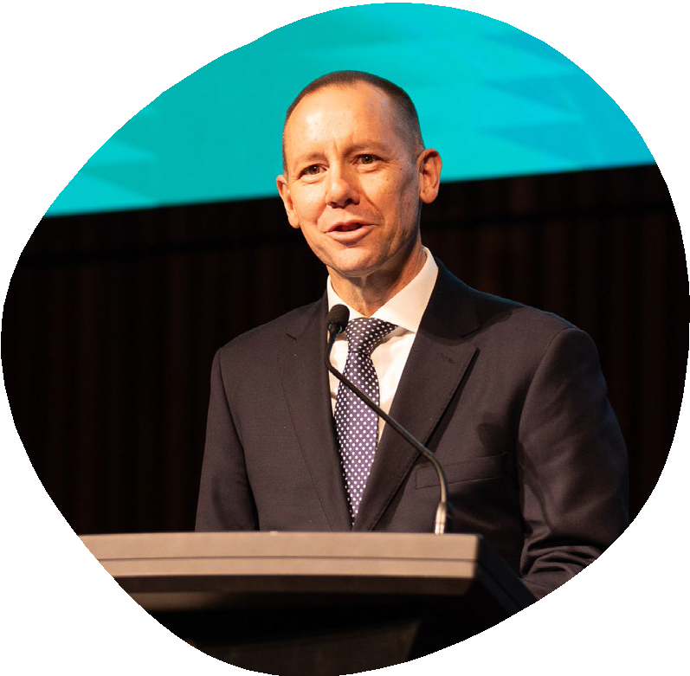
Randall Brugeaud, Head of the STS Taskforce, shared the vision for the STS reforms including simplifying and aligning rules and processes, reducing duplication, and creating more modern sustainable digital services. He highlighted
the importance of being joined up across government having business at the centre of the reforms. He highlighted that the current system is costly and complex, and this is impacting Australia’s competitiveness. He noted the goal for Australia to reclaim its place as a world leader in cross-border trade, one that drives efficiency, sustainability and productivity benefits for all Australians.

Morning plenary discussions

Global trade outlook
This discussion emphasised the need for government action to foster collaboration, enhance digital capabilities, and optimise trade processes to seize opportunities and mitigate risks in the face of an increasingly contested geopolitical environment. The panel highlighted the importance of productivity growth and scaling up digital capabilities
to improve economic competitiveness. Simplified trade processes were identified as a key factor in remaining competitive, with plurilateral negotiations and keeping doors open to all parties being essential for enhanced cooperation with key trading partners. The opportunities presented by the new Western Sydney Airport were also discussed, emphasising the need for stable
and sustainable trade processes and supply chains. Overall, there was a call to prioritise collaboration, digital advancements, and optimised trade processes to maximise productivity and ensure sustainable and adaptable international trade.

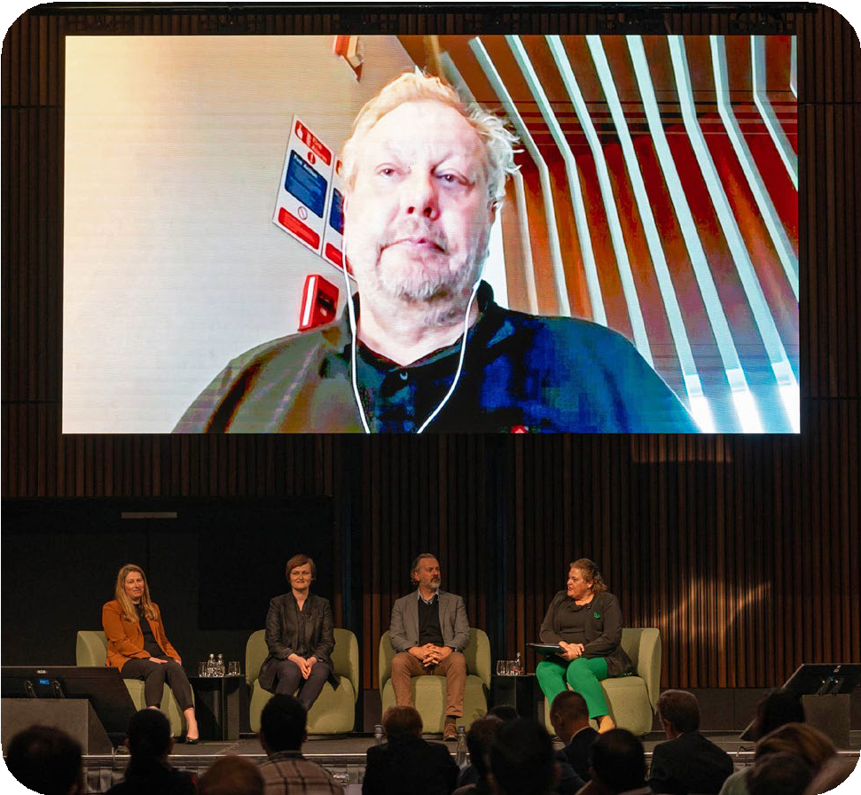
Kate Pounder (Chief Executive Officer, Technology Council of Australia) Stela Solar (Director, National Artificial Intelligence Centre, CSIRO) Adrian Turner (Chief Executive Officer, Board of Directors, ExoFlare) Michelle Dowdell (Chief Economist and Head of Division, Department of Industry, Science and Resources) and Richard White (CEO and Founder WiseTech Global).

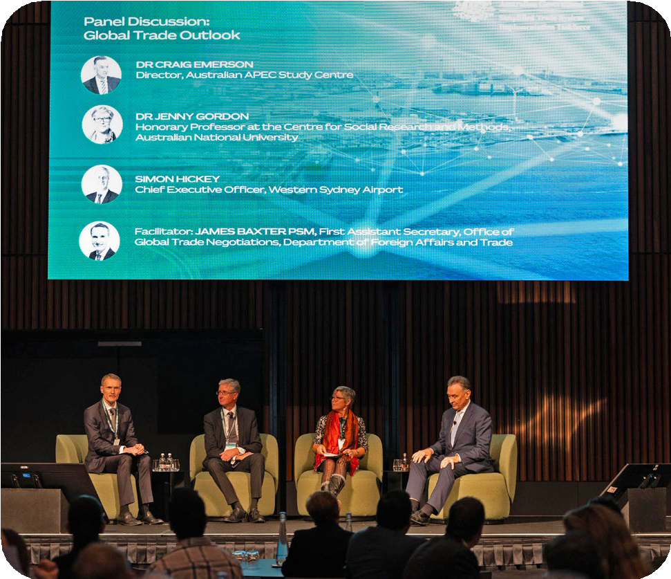

James Baxter PSM (First Assistant Secretary, Office of Global Trade Negotiations, Department of Foreign Affairs and Trade), Simon Hickey (CEO, Western Sydney Airport), Dr Jenny Gordon (Honorary Professor at the Centre for Social Research and Methods, Australian National University) and Dr Craig Emerson (Director, Australian APEC Study Centre).

Disrupt or adapt
This panel explored the imperative of embracing disruption and maximising its benefits in the context of cross-border trade reform and economic productivity. Key insights included the need for Australia’s trade environment
to keep pace with global developments, particularly in the realm of e-commerce and cargo management. The panel highlighted the importance of a single window system for
whole-of-government to enhance productivity. Discussion focused on managing biosecurity threats using advanced technologies,
such as surveillance and incident response systems. The transformative potential of artificial intelligence was identified, including its ability to handle scale, complexity, and precision in cross-border trade processes.
The session also stressed the significance of digital literacy, effective use of industry
capabilities, and holistic approaches to leverage technologies effectively.

Afternoon panel discussions

Building blocks for paperless trade
In this session the panel delved into the transformative potential of digitalisation and paperless trade, highlighting its ability to
enhance efficiency, reduce costs, and improve transparency. The session emphasised the need for strategic reform by both government and businesses. Insights from industry leaders highlighted the evolving trade environment, the challenges faced by small and medium-sized enterprises in cross-border trade, and successful examples of implementing paperless trade. Key building blocks identified included reducing trade facilitation costs, ensuring supply chain transparency, and the need for streamlined processes and support. The panel discussed the benefits of paperless trade,
such as saving time, verifying authenticity,

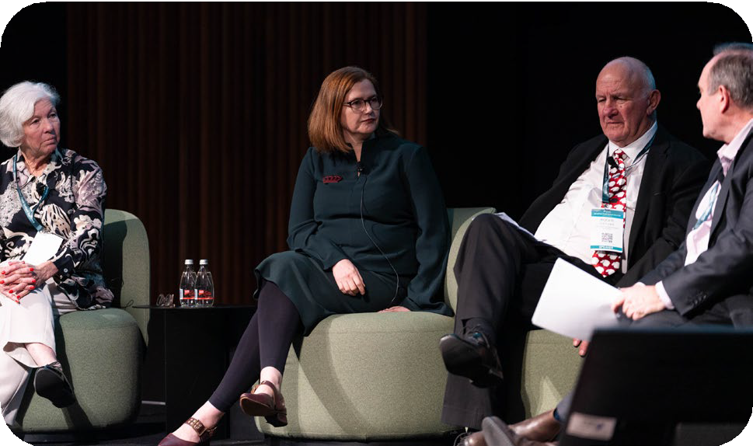

Dianne Tipping (Chair, Export Council of Australia), Louise McGrath (Head of Industry Development and Policy, Australian Industry Group), Roger Fletcher OAM (Managing Director and Founder, Fletcher International Exports) and Matt Koval PSM (Deputy Secretary, Department of Agriculture, Fisheries and Forestry).

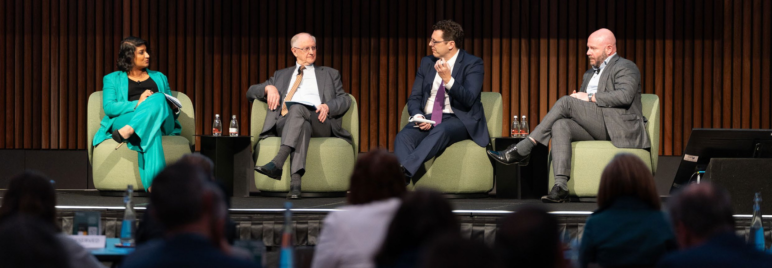
and responsiveness to food security needs. Opportunities for flexibility in regulations, traceability improvements, and engaging trading partners were also discussed. The session called for increased communication, training, and public information sessions to ensure all stakeholders are aligned on the paperless trade journey, with a focus on highlighting the value, market access, and Environmental Social and Governance-related advantages associated with digitalisation.
STS Summit Outcomes 2023
5

Productivity and opportunities in international trade
The role of trade reform, international standards, and efficient regulatory fundamentals in improving productivity and creating opportunities for Australian businesses were key focus points for this panel. The discussion highlighted the need to upgrade and modernise the trade system and focus on trade liberalisation to enhance productivity and prosperity. They discussed the importance of making regulations and systems smarter, adapting the workforce for the future, and prioritising education, migration, industrial relations, and occupational licensing. The panel also underscored the significance of international standards in enabling trade, emphasising the need for common understanding and the avoidance of bespoke standards. They called for active engagement in the development and updating of international standards to support the reform agenda. Additionally, the panel discussed the alignment of industry policy with trade policy and the importance of multilateral and plurilateral engagement. Actions proposed for government and industry included promoting trade liberalisation, encouraging the use of international standards, strategic engagement in multilateral forums, and implementing reforms to enhance productivity.

Mohita Zaheed (First Assistant Secretary, Labour Market, Environment, The Treasury), Professor Peter Drysdale AO (Professor, Australian National University), Dr Alex Robson (Deputy Chair, Productivity Commission) and Adam Stingemore (General Manager, Engagement and Communications, Standards Australia).

Trading with trust
The importance of open collaboration, transparency, and strong cybersecurity measures to support digital transformation and protect data were key themes of this panel discussion. The members highlighted the need for organisations to work with external partners and other stakeholders to ensure the security and safety of customer data. Key challenges discussed included data protection, digital identities, trust standards, and the role of government in cybersecurity. The panel discussed the importance of global standards, sharing intelligence to prevent
common threats, and focusing on foundational security measures. Recommendations included adopting established security frameworks, building trust through consistent regulation, and addressing core issues rather than adding layers of security. The session also discussed the role of distributed ledger technology, the responsibilities of small and medium-sized enterprises in cybersecurity, and the barriers

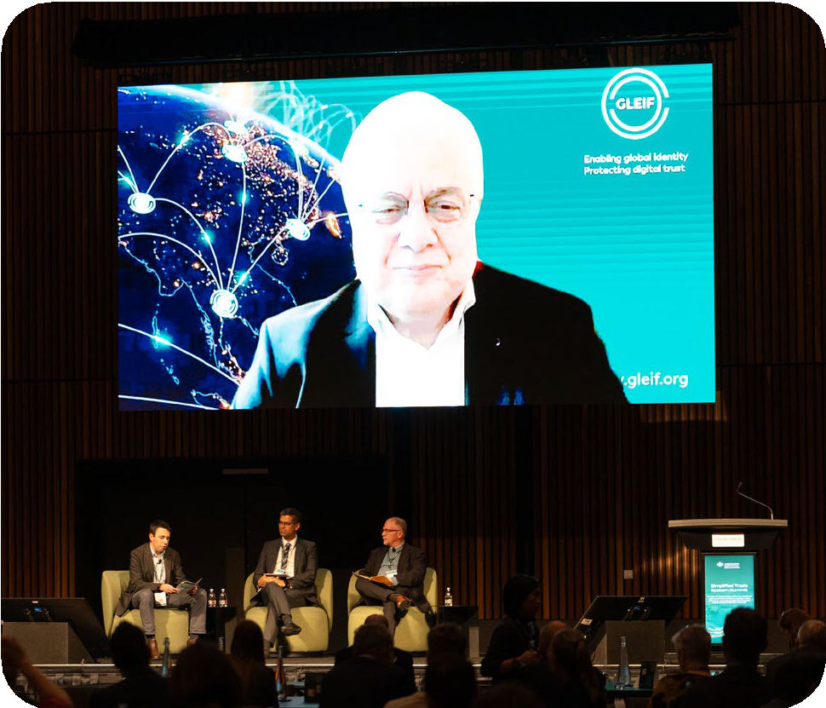
Jordan Hatch (Assistant Secretary, Department of Finance), Sandro Bucchianeri (Chief Security Officer, National Australia Bank), Adam Rice (Cyber Security Advisor, CISCO) and Stephan Wolf (Chief Executive Officer, Global Legal Entity Identifier Foundation (GLEIF).

to the uptake of digital credentials. The panel agreed that trust and security are inseparable
and called for increased inclusion and collaboration to enhance trust and strengthen security measures. They outlined key focus areas for both government and industry include promoting open collaboration, establishing national approaches to digital credentials, and prioritising proactive threat intelligence and openness when addressing cyberattacks.

Navigating interoperability through data
This panel discussed the importance of leveraging common data standards and global standards to simplify compliance and improve risk management. The conversation highlighted the role of data interoperability in modernising government and business processes, enabling systems to communicate effectively and maximise the use of data. Panel members emphasised the need for government to draw on global data standards to enhance processes at the border and stressed that utilising these standards is crucial for staying competitive in the global trade landscape. The panel also discussed the evolution of digital services, the challenges of identity fraud in the digital realm, and the importance of public-private partnerships to combat cybercrime. The session called for adopting data standards to drive commercial uptake, removing complex regulatory requirements by understanding data elements and securing stakeholder buy-in, and establishing trust in data from overseas merchants through validation and standards-based approaches. The panel also discussed the need for government and industry collaboration to achieve streamlined systems, improved data interoperability, and the benefits of standardised processes in
cross-border trade.

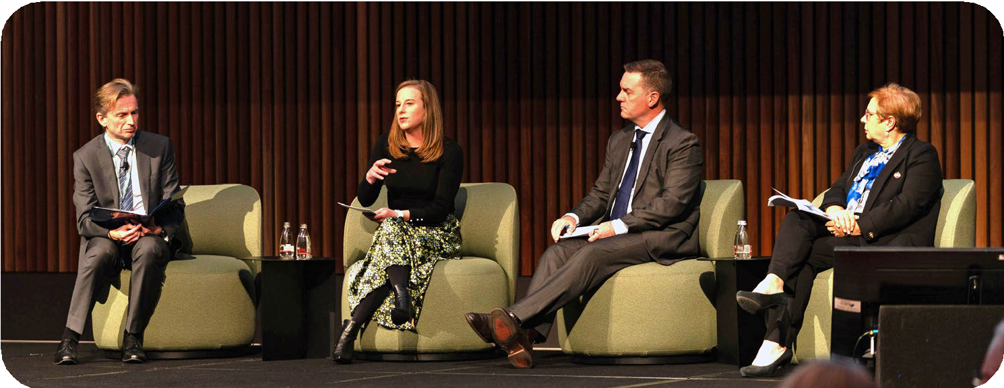
Jeremy Hirschhorn (Second Commissioner, Client Engagement Group, Australian Taxation Office), Erin Adams (Product Compliance and Industry Engagement Manager, Xero), Chris Sheehan (Executive, Group Investigations & Fraud, National Australia Bank) and Maria Palazzolo (CEO, GS1).

Global perspectives on trade modernisation – The international experience
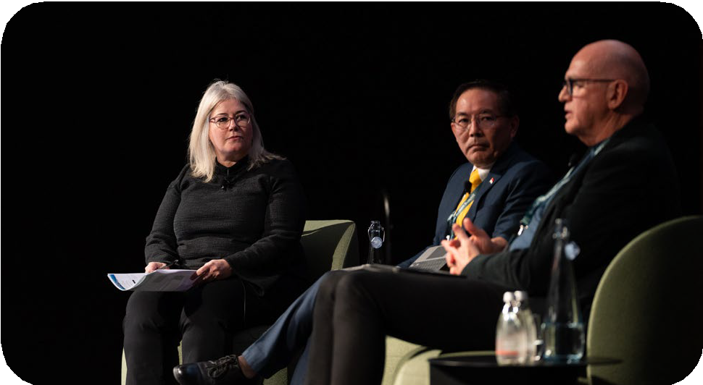
The panel session highlighted the importance of learning from other nations’ experiences to guide Australia’s journey towards trade modernisation. The need for commitment, collaboration, and political sponsorship in driving successful modernisation efforts
was discussed. Insights from panel members showcased the challenges faced during the modernisation process and the key factors contributing to success. The experiences of the US highlighted the importance of transparency

and cross-agency cooperation, while Singapore’s success factors included strong political sponsorship and continuous adaptation to changing technologies.
Kaylene Zakaroff (Deputy Commissioner, Strategy and Capability Group, Australian Border Force), Sin Yong Loh (Director, Infocomm Media Development Authority), Mark Kellett (CEO UAC International) and Vincent Annunziato (Director, Business Transformation & Innovation Division, U.S. Customs and Border Protection) off screen.

The panel also emphasised the need for collaboration with key trading partners, such as New Zealand, Singapore, and the US, to align and integrate systems. Actions proposed for government and industry included reducing duplication and charges to businesses, developing a roadmap for early benefits, and engaging the business community throughout the reform process. Overall, the panel acknowledged the importance of addressing obstacles faced by transformations, such as data duplication and human resistance to change.

Charting the course for digital regulation – Compliance by design
The need for new regulations to fully benefit from tomorrow’s opportunities and avoid retrofitting new digital systems onto outdated regulatory regimes were highlighted in this panel session. The discussion emphasised the importance of regulatory reform and coordination between various stakeholders to achieve effective trade facilitation. Examples from international jurisdictions, such as the UK, EU, and US, were cited to demonstrate the progress being made in modernising approaches to regulation. The panel also discussed the role of technology, including blockchain,
in integrating regulatory frameworks and logistics, enabling seamless collaboration between regulators and businesses. Actions proposed for government and industry included embracing digital transformation, fostering coordination and collaboration between regulators, policy makers, and the private sector, and considering global harmonisation of digital regulations in areas like document verification and potential to adopt the UN Model Law of Electronic Transferable Records. The panel cautioned against relying solely on government capabilities, stressing the need for adaptable solutions that can keep up with rapidly evolving technology and future demands.

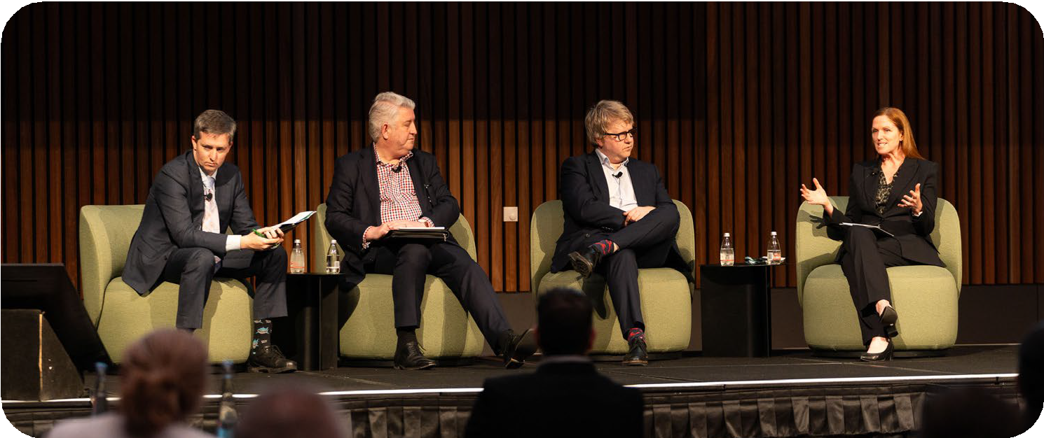
Dr Paul Hubbard (Deputy Head, Simplified Trade System Implementation Taskforce), Andrew Hudson (Partner, Rigby Cooke Lawyers), Chris Berg
(Co-founder and Co-director, RMIT Blockchain Innovation Hub, RMIT University) and Belinda Dennett (Corporate Affairs Director, Microsoft ANZ).

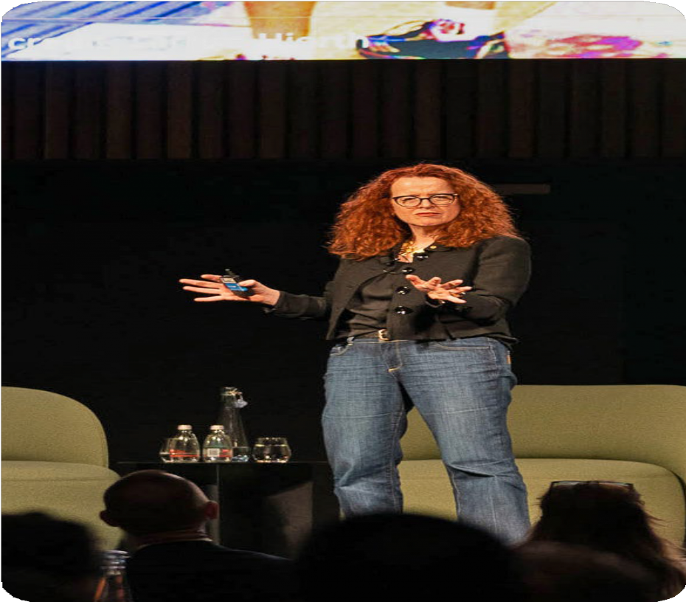
Closing keynote address
Professor Genevieve Bell, a renowned cultural anthropologist, technologist, and futurist, delivered the closing keynote titled “Distribution of the Future.” In her thought-provoking presentation, she urged the audience to broaden their perspective on the future and consider the humans who will inhabit it. Professor Bell highlighted the importance of understanding these five key areas—time, place, power, stories, and humanness—to navigate the complexities and uncertainties of the future effectively.
These themes resonate strongly with the agenda of simplifying Australia’s trade environment. Understanding how time, place, power, stories, and humanness intersect with trade can provide valuable insights for decision-makers. Professor Bell's keynote emphasised the importance of acknowledging these key areas to ensure a resilient and effective trade system
that adapts to the evolving landscape and promotes sustainable and inclusive global commerce. By embracing these concepts, stakeholders can navigate the complexities and uncertainties of the future, making informed decisions to streamline and enhance our cross-border trade.

Professor Genevieve Bell AO, Director of the School of Cybernetics, Australian National University.

On display

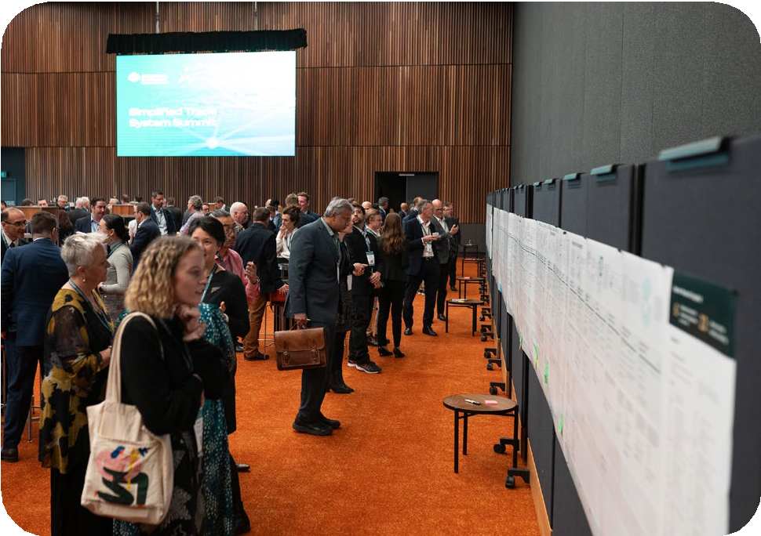
Importer and exporter journey maps
The STS Taskforce shared the end-to-end, whole-of-trade view of import and export user journeys. These 24 metres of journey maps were developed as part of the STS baselining work. As an output of research conducted with Australian businesses, the journey maps
presented a whole-of-government view of what exporters and importers might need to navigate to get products across Australian borders.
The journey maps prove that great discussions with attendees have helped to improve our
understanding of the current environment. Attendees examine and contribute to importer and exporter
journey maps.

Austrade’s Go Global Toolkit being presented to Minister Farrell.

Austrade Go Global Toolkit
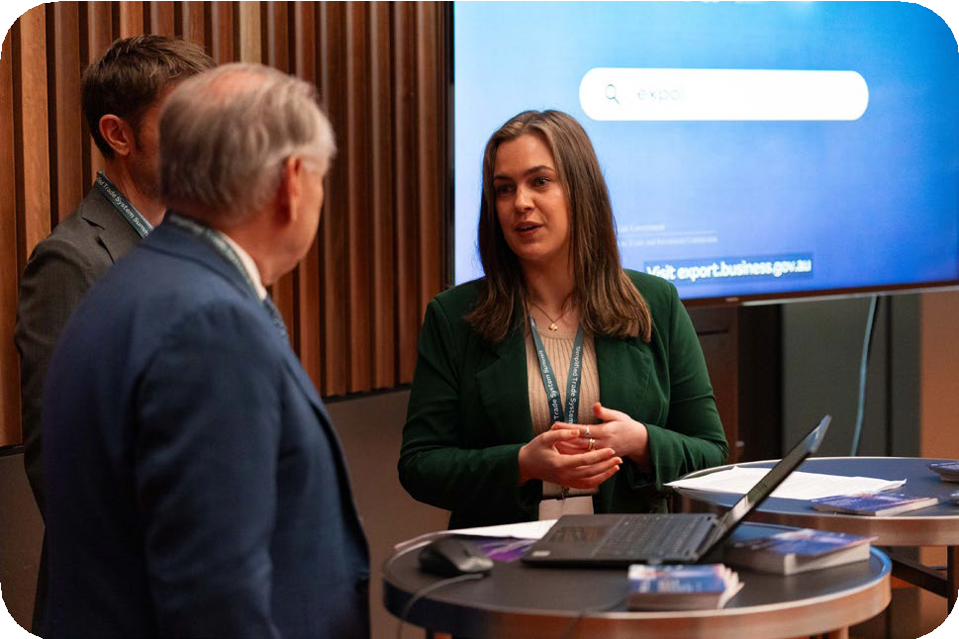
Austrade’s Go Global Toolkit (GGT) was showcased, covering over 6,300 products and 120 markets, the GGT is making exporting easier with information, tools and support all in one place. Austraders were on hand to show Summit attendees why businesses using the toolkit are saving between 520 and 1370 hours on their export journey. Audiences were eager to hear how the toolkit was helping service exporters. Feedback was particularly positive around the search engine functions for tariffs & regulations, and the customization of the export plan.

Next steps
- The STS Taskforce, with partner agencies, will continue to engage with stakeholders across government, industry, academia and the broader community to pursue ongoing, meaningful dialogue on the key themes explored at the STS Summit.
- The STS Taskforce is encouraging all attendees and interested stakeholders to provide input to the next stage of reforms through the 2023 STS Consultation Paper. Consultation is open until 24 July 2023. The consultation paper is available at: www.simplifiedtrade.gov.au
- The plenary and panel sessions were interactive to maximise audience participation. The STS Taskforce is currently working on a set of Frequently Asked Questions to respond to questions captured on the day. These will be shared with STS website subscribers and
followers of the STS LinkedIn page. As always, general comments and feedback would be welcomed at www.simplifiedtrade.gov.au/contact-us

Appendix 1: Agenda at a Glance

Time | Event
8:30am | Registration and Arrival Tea & Coffee
9:00am | MC Welcome | Grand Hall 2  Div Pillay, Chief Executive Officer, MindTribes and Co-founder, Culturally Diverse Women
9:05am | Welcome to Country Wurundjeri Elder Perry Wandin
9:10am | Ministerial Address  Senator, the Hon Don Farrell, Minister for Trade and Tourism and Special Minister of State
9:20am | Industry Address  Mr Paul Little AO, Chair, STS Industry Advisory Council
9:30am | Ministerial Address  The Hon Clare O’Neil MP, Minister for Home Affairs (Pre recorded message)
9:40am | Head of Taskforce Address  Mr Randall Brugeaud, Head, Simplified Trade System Implementation Taskforce
9:50am | Keynote Address  Jennifer Westacott AO, Chief Executive, Business Council of Ausralia
10:20am | Ministerial Address  Senator, the Hon Murray Watt, Minister for Agriculture, Fisheries and Forestry (Pre recorded message)
10:30am | Morning Tea
11:00am | Panel Discussion: Global trade outlook | Grand Hall 2  In an increasingly contested geopolitical environment, what is the outlook for international trade? What can we do to seize opportunities and mitigate risk? And how do we take advantage of the trade facilitation agenda to boost trade?  Dr Craig Emerson, Director, Australian APEC Study Centre  Dr Jenny Gordon, Honorary Professor at the Centre for Social Research and Methods, Australian National University  Simon Hickey, Chief Executive Officer, Western Sydney Airport  Facilitator: James Baxter PSM, First Assistant Secretary, Office of Global Trade Negotiations, Department of Foreign Affairs and Trade
11:45am | Panel Discussion: Disrupt or adapt | Grand Hall 2  In a world characterised by rapid change, how do we embrace disruption to adapt and maximise the potential benefits? A unique opportunity to discuss emerging trends and the implications for cross-border trade reform and economic productivity.  Kate Pounder, Chief Executive Officer, Technology Council of Australia Stela Solar, Director, National Artificial Intelligence Centre, CSIRO Adrian Turner, Chief Executive Officer, Board of Directors, ExoFlare Richard White, Chief Executive Officer and Founder, WiseTech Global  Facilitator: Michelle Dowdell, Chief Economist and Head of Division, Department of Industry, Science and Resources
12:30pm | Lunch
1:30pm | Breakout Session One | Panel A: Grand Hall 2 | Panel B: Grand Hall 3
1:30pm | Panel A: Building blocks for paperless trade  Paperless trade has been a focus for governments and industry for many years. Removing paper from trade flows reduces risk and saves costs for business, and government. What are the lessons learned and actions required to realise the benefits of digitisation and data sharing, while continuing to support participation of SMEs and new traders?  Roger Fletcher OAM, Managing Director and Founder,  Fletcher International Exports  Louise McGrath, Head of Industry Development and Policy, Australian Industry Group  Dianne Tipping, Chair, Export Council of Australia  Facilitator: Matt Koval PSM, Deputy Secretary,  Department of Agriculture, Fisheries and Forestry | Panel B: Productivity and opportunities in international trade  International trade is critical to the Australian economy with our cross-border goods and trade now worth over one trillion dollars. Even small regulatory changes have the potential to unlock significant savings for government, business and consumers.  What is the opportunity to lift productivity and create opportunities for Australian businesses.  Professor Peter Drysdale AO, Professor, Australian National University  Dr Alex Robson, Deputy Chair,  Productivity Commission  Adam Stingemore, General Manager, Engagement and Communications, Standards Australia  Facilitator: Mohita Zaheed, First Assistant Secretary, Labour Market, Environment, The Treasury

Time | Event
2:15pm | Breakout Session Two | Panel A: Grand Hall 2 | Panel B: Grand Hall 3
2:15pm | Panel A: Trading with trust  The global international trade landscape is rapidly evolving. How do we maintain trust while maximising innovation. How can we maintain data protection and cyber security controls as we leverage digital identities and optimise data sharing between government, intermediaries and business.  Sandro Bucchianeri, Chief Security Officer, National Australia Bank  Adam Rice, Cyber Security Advisor, CISCO  Stephan Wolf, Chief Executive Officer, Global Legal Entity Identifier Foundation (GLEIF)  Facilitator: Jordan Hatch, Assistant Secretary,  Department of Finance | Panel B: Navigating interoperability through data  Businesses use their own systems and data to reduce fraud and ensure regulatory compliance. The private sector has developed standards to classify and track goods through complex supply chains. There are good examples of where Government has made it  easier for business to comply, the tax system is one of them. What are the opportunities to leverage natural business data and global standards to make it easier to comply and better manage risk?  Erin Adams, Product Compliance and Industry Engagement Manager, Xero  Maria Palazzolo, Chief Executive Officer, GS1  Chris Sheehan, Executive, Group Investigations & Fraud, National Australia Bank  Facilitator: Jeremy Hirschhorn, Second Commissioner, Client Engagement Group, Australian Taxation Office
3:00pm | Afternoon Tea
3:15pm | Breakout Session Three | Panel A: Grand Hall 2 | Panel B: Grand Hall 3
3:15pm | Panel A: Global perspectives on trade modernisation – The international experience  Australia lags its key trading partners in international trade performance. What can we learn from other nations about their experience in modernising their trade environment?  Vincent Annunziato, Director, Business Transformation & Innovation Division, U.S. Customs and Border Protection  Mark Kellett, Chief Executive Officer,  UAC International  Sin Yong Loh, Director, Infocomm Media Development Authority  Facilitator: Kaylene Zakaroff, Deputy Commissioner, Strategy and Capability Group, Australian Border Force | Panel B: Charting the course for digital regulation – Compliance by design  Australia’s cross-border trade regulations have been introduced at different times to achieve historic revenue and regulatory outcomes. Current policy pressures to embed further regulatory goals, environmental, social and governance means regulation may need to do more. Rather than retrofitting new digital systems onto legacy  regulatory regimes how can new regulations take full benefit of tomorrow’s opportunities?  Chris Berg, Co-founder and Co-director, RMIT Blockchain Innovation Hub, RMIT University  Belinda Dennett, Corporate Affairs Director,  Microsoft Australia New Zealand  Andrew Hudson, Partner, Rigby Cooke Lawyers  Facilitator: Dr Paul Hubbard, Deputy Head, Simplified Trade System Implementation Taskforce
4:00pm Closing Session Keynote | Grand Hall 2
In 2023, science fiction author William Gibson declared that the future is already here, it just unevenly distributed”. This helps us make sense of the digital transformation taking place globally and impacted all sectors including trade. Genevieve Bell will reflect on the distribution of the past 2-3 years and tease out 5 threads to help decision makers better understand and think critically about the ways the individuals and group’s function and engage to reveal glimpses of what’s to come.
Professor Genevieve Bell AO, Director of the School of Cybernetics, Australian National University 4:30pm Networking event
5:30pm Event close

