THRIVE 2030 Implementation Advisory Group (TIAG)

Summary of Meeting – 4 December 2023
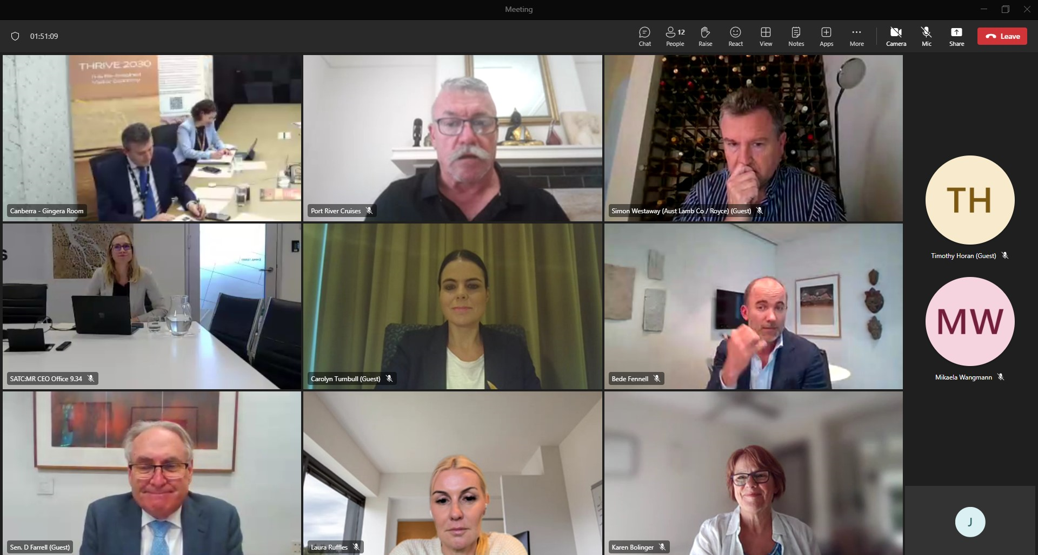
The fourth meeting of the THRIVE 2030 Implementation Advisory Group (TIAG) was held on Monday 4 December. The meeting was chaired by Austrade CEO, Xavier Simonet. Members discussed implementation progress of the THRIVE 2030 Phase 1 Action Plan. The Minister for Trade and Tourism, Senator the Hon Don Farrell, joined to hear members’ views on priorities and opportunities for the final year of Phase 1 and ideas for the development of the Phase 2 Strategy Action Plan.

THRIVE 2030 Strategy implementation update
Members were provided with an implementation report, which detailed progress against each of the 64 strategic actions under Phase 1 of THRIVE 2030. Of these 64 strategic actions, ten are completed, 51 are underway and three are pending. The report also noted that, as of the year ending June 2023, THRIVE 2030’s visitor expenditure target for Phase 1 had been exceeded. The total visitor economy spend (including long-term international students) reached $191.4 billion, of which $79.9 billion was spent in regional Australia. It was noted strong continuing interest in travel and price increases (in part) have contributed to achievement of these targets.

Austrade provided a brief overview of key pieces of THRIVE 2030 work since the last advisory group meeting in May 2023. Achievements include: release of the IDEA Working Group Report and Recommendations, Employment White Paper, and the Visitor Economy Workforce and Skills Interim Action Plan 2023-24; Tourism Ministers’ launch of a National Sustainability Framework and Sustainable Tourism Toolkit for business; investment into National Parks and Caravan Parks; release of the Aviation Green paper; success of Tourism Australia’s Come and Say G’day international marketing campaign; release of the Australian Government’s Southeast Asia Economic Strategy (including a chapter on the visitor economy); recommencement of the China Approved Destination Status scheme; and Government investment to enhance the Quality Tourism Framework. A range of industry and State and Territory initiatives noted in the implementation report were also highlighted.

Discussion: TIAG and Minister for Trade and Tourism
Members provided their feedback on the progress of THRIVE 2030 Phase 1 Action Plan implementation before being joined by the Minister for Trade and Tourism, Senator the Hon Don Farrell. As the THRIVE 2030 Strategy moves into the final year of Phase 1 and development of Phase 2, Members shared their views on new ideas and opportunities.

Key themes that emerged from the discussion include:
- The Australian Government’s initiatives to increase income for pensioners and veterans were welcomed. While workforce capacity has improved, ongoing difficulties in accessing and keeping skilled workers were noted, particularly in regional areas.
- Further support for SMEs and businesses in regional areas to build digital capability and/or encourage innovation was encouraged.
- Leveraging of large-scale events, including sport and business events, to boost visitation and increase appetite for repeat travel to Australia was encouraged. The success of the FIFA Women’s World Cup and other world events was highlighted, alongside opportunities presented by upcoming events in Australia.
- The Australian Government’s investment in tourism infrastructure, including caravan parks, was commended with encouragement for further investment/grants to support accommodation providers as had previously been Government funded and delivered by Austrade. Further focus on attracting investment under Phase 2 was encouraged.
- The recent launch of a National Sustainability Framework and industry toolkit was welcomed. Sustainability and demonstration of credentials is now a given across the sector. Further work to streamline messaging for industry was encouraged along with take up of the new resources.
- Opportunities presented by diversification of tourism markets and experiences, including further development of accessible tourism and First Nation’s tourism product were discussed.
- While visa reform through the Migration Strategy was anticipated, challenges relating to visa processing continue, particularly for groups of business travellers and arranging extensions for tourism workers, including Working Holiday Makers.
- Importance of increasing international and domestic aviation capacity and improving reliability of domestic transport services through the Aviation White Paper process and alignment with THRIVE 2030 was noted.
- Importance of improving awareness within industry of THRIVE 2030 and the good work being delivered was discussed.
- The consideration of new targets for Phase 2 suggested as an opportunity to increase a broader focus on inputs to supporting growth and increasing the Strategy’s profile was flagged.

The Minister thanked members for their views and ongoing contribution to support the work of THRIVE 2030. He noted that his recent trips to Japan, China and the United States had indicated there was pent-up consumer demand for travel. The Minister was optimistic about growth across international markets, with some like Vietnam already surpassing 2019 levels of visitation. Ongoing workforce challenges were acknowledged. He highlighted the Australian Government’s commitment to resolve these issues through the review of visa systems and increased investment in skills and training, noting producing homegrown workers would increase the long-term resilience of Australia’s tourism workforce. He reported programs under the Australian Government’s $48 million tourism and travel package were producing outcomes, citing caravan parks modernising infrastructure to make facilities more accessible.

