Discussion paper:
International Diversification Strategy for the Visitor Economy
An Action of THRIVE 2030 – Australia’s national strategy for the long-term sustainable growth of the Australian visitor economy

Supporting Priority 6: Build Markets and attract visitors of the THRIVE (The Re-Imagined Visitor Economy) 2030 strategy: Austrade invites industry to contribute thoughts on a national strategy to rebuild sustainable and resilient international visitor markets for the future.
The purpose of this discussion paper is to:
- present early findings on opportunities to diversify Australia's visitor economy in existing and emerging source markets gained through an analysis of Australia’s market performance since 2010 and initial industry consultations, and
- present governments, researchers, organisations and industry an opportunity to provide feedback on this work. This feedback will be used to inform a Visitor Economy International Diversification Strategy.
The insights and views presented in this paper represent preliminary thinking and therefore should not be interpreted as Australian Government policy.
A consultation period will follow this discussion paper’s release. Austrade welcomes submissions via visitoreconomy@austrade.gov.au up until 13 July 2023.
An easy and fast way to engage is through the Visitor Economy Diversification Stakeholder Consultation Survey, available at the Austrade website.
All submissions will be treated as public and may be published on the Austrade website, unless the author specifically requests that the submission, or part thereof, be handled in confidence.
Unless otherwise requested, Austrade will publish the submission and the name of the submitting organisation or individual on its website. Austrade will not edit submissions prior to publishing. By making a submission, the author(s) agree to their submission, or part thereof, being used by the Commonwealth of Australia for Commonwealth purposes.

Austrade values building strong and productive relationships with Aboriginal and Torres Strait Islander peoples. We recognise, value and celebrate Aboriginal and Torres Strait Islander peoples’ enduring connection to land, waters and communities. We know there is a deep history and seek to support its continuation. We pay our respects to elders past and present.  Reconciliation Action Plan - Austrade | 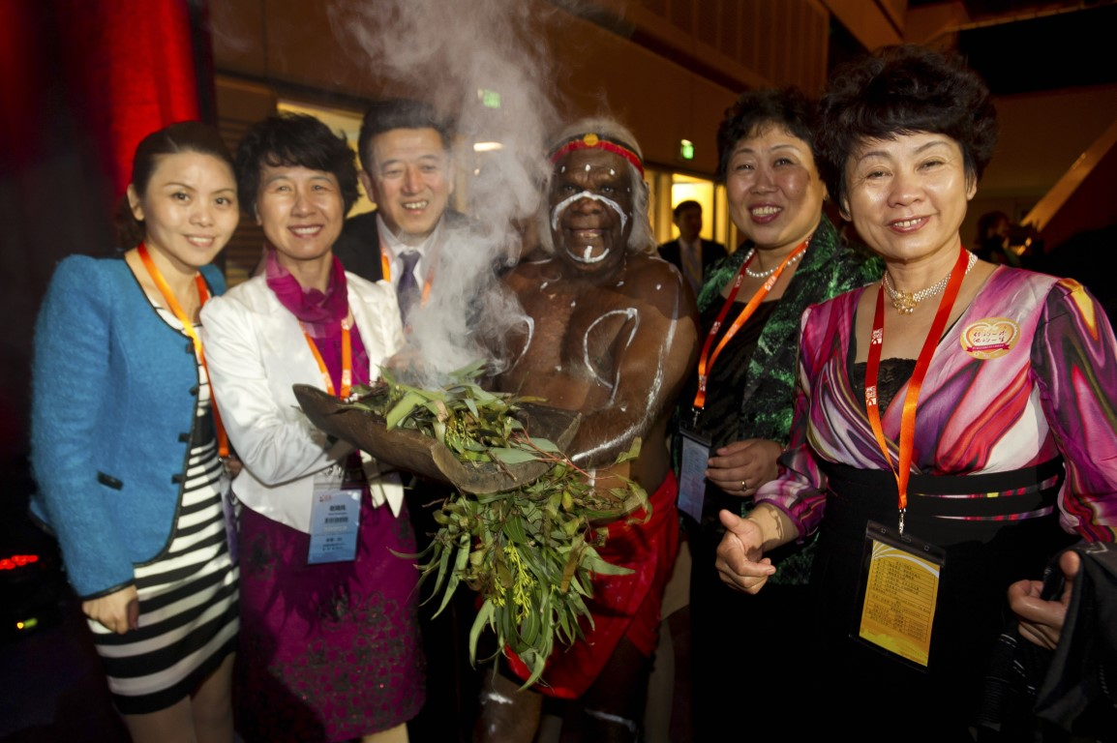”Perfect China” Incentive Event, 2013 (Tourism Australia)

All images in this document are supplied by the Tourism Australia Image Gallery and remain the copyright of the credited entity.
Cover image: A beachside meal at Tangalooma Island Resort, Moreton Island, Queensland (Tourism Australia)

Executive Summary
As the world recovers from the pandemic, global travel trends and demand drivers are changing, shifting markets to provide new opportunities for Australia’s visitor economy. While it is important that Australia continues to focus on recovering its share of our traditionally high volume and high yielding Western and North Asian priority markets, new traveller behaviour, strong economic growth in the Indo-Pacific region and the Australian Government’s desire to strengthen strategic relationships through the growth of people-to-people links all offer opportunities over the coming decades to further diversify Australia’s source markets for international visitation.
To grow emerging visitor markets and build market share in the Indo-Pacific region, there will be a need for complementary measures to develop unique, high-quality, culturally relevant, accessible, inclusive and appealing visitor propositions to attract a diverse mix of high-yielding visitors from these markets, while increasing industry readiness to service these travellers. Governments and industry will also need to work closely to build supply chains, remove travel frictions and develop appealing product and experiences to grow market share from emerging markets, and in doing so support the development of an inclusive and diverse industry that includes providing increased opportunities for indigenous businesses.
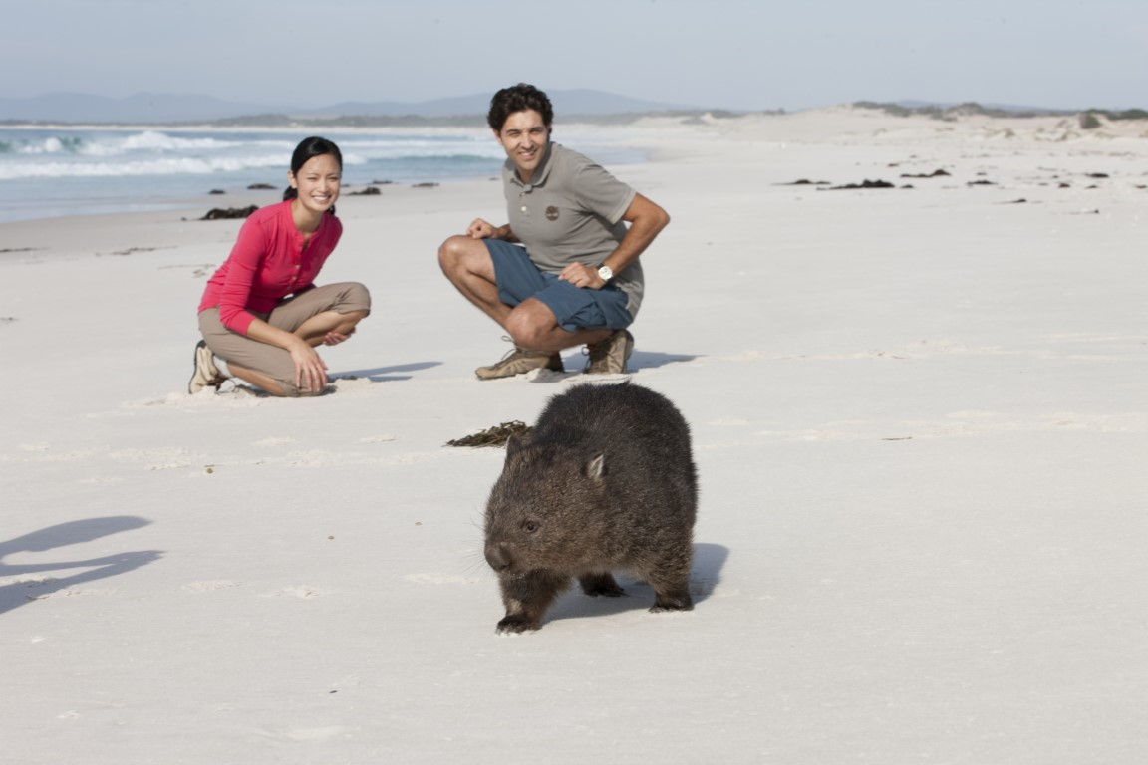
While success in new markets will require a long-term commitment and investment from governments and industry, a broad and balanced portfolio of source markets and market segments is key for a prosperous and more resilient visitor economy in the decades ahead. This paper for industry consultation provides an overview of Australia’s international visitor economy and puts forward for discussion emerging markets and traveller segments that could help achieve
THRIVE 2030 targets and improve the resilience of Australia’s visitor economy.
Bay of Fires, Tasmania (Tourism Australia)

1. The case for market diversification

1.1 Introduction
The COVID-19 pandemic has been a watershed moment for Australia’s $166 billion visitor economy. Never has the contribution that international visitors make to Australia’s economy been so evident. With borders having largely reopened and industry refocusing on international markets, there is a unique opportunity to re-evaluate and reinvigorate relationships and strategies to ensure a more resilient and sustainable visitor economy that takes advantage of new opportunities in this post-pandemic environment.
As set out in the THRIVE 2030 Strategy for the visitor economy, building markets and attracting high-value visitors through coordinated, innovative, focused and personalised visitor attraction strategies that are targeted at a re-balanced mix of domestic and international markets will be the cornerstone of a prosperous visitor economy.
This discussion paper focusses on taking forward THRIVE 2030 Action Item 6.3:
“Develop an International Diversification Strategy to identify emerging markets for travel and education; strengthen key bilateral relationships in the Indo-Pacific region and beyond through the growth of people-to-people links and Brand Australia marketing.”
Diversification is one way to balance risk and reward. Diversification in the visitor economy context is a strategy of attracting visitors from a wide range of international markets and market segments so that exposure to any one set of market risks is reduced. A focus on high-value visitors and greater market diversification will be an important component in supporting a more resilient Australian visitor economy that is less susceptible to future shocks.
This work is also consistent with and supports both the Australian Government’s broader trade diversification agenda and its strengthened engagement in our region, including through the development of a Southeast Asia Economic Strategy to 2040. These seek to build Australia’s economic resilience and support future prosperity through maximising opportunities in global markets and strengthening our economic partnerships across the Indo-Pacific region.
Australia will continue to welcome visitors from all markets, both traditional and new. Diversifying is about attracting a broader set of travellers from new and emerging markets to help future proof the Australian visitor economy, should future shocks or disruptions to traditional major traveller markets occur. Targeting a broad portfolio of source markets and traveller types will require governments and industry to work together to create suitable product and address impediments in developing these new opportunities.

1.2 Dimensions of diversification
Diversification is not only about building new international markets, but also about seeking out a diverse range of high-yielding market segments that have a strong positive impact on the visitor economy. The opportunities and strategies to diversify the leisure and student segments will be different for each market and will need to be tailored accordingly. While intrinsically linked to leisure and education, the growing Visiting Friends and Relatives (VFR) and Working Holiday Maker (WHM) market segments have also increased in their importance over the pandemic recovery period and need to be given consideration. Tourism Australia’s new Future of Demand research will assist Australian operators to develop their tailored strategies for emerging segments through the provision of insights into 143 different experiences across 20 international markets and four target audiences.
Opportunities also exist to grow market share in priority segments such as accessible tourism, sustainable tourism, First Nations tourism, events and travel for employment or “bleisure” travellers, who mix business and leisure travel. This paper, therefore, takes a broad view of the various sectors within the visitor economy, highlighting the interrelationships and factors within them that influence overall visitation.
The COVID-19 pandemic demonstrated the agility and resilience of the industry in pivoting quickly and effectively towards the domestic market which was, and continues to be, more significant in earnings than the international market. Industry can continue to strengthen its resilience by enhancing domestic growth as part of an overall diversification strategy. However, while diversification of the domestic market, especially through focussing on different market segments, is significant and important work for the industry, the focus of this paper is on the potential for diversifying Australia’s international markets.

1.3 Diversification strategy purpose
Through this lens, a Visitor Economy International Diversification Strategy (the Strategy) led by the Australian Trade and Investment Commission (Austrade), in cooperation with Tourism Australia (TA), the Department of Foreign Affairs and Trade (DFAT), State and Territory Tourism Organisations (STOs) and industry, will identify emerging markets and traveller segments that show the most potential to grow and complement the current mix of international source markets, and the role for industry and governments in supporting and driving that diversification through product development.
While businesses will ultimately make their own decisions on which markets to create, build product for and engage with, there are several levers that governments and industry can use to raise awareness of opportunities, provide support, remove frictions, generate suitable product and drive demand.
This discussion paper presents findings of initial work undertaken by Austrade to ascertain industry’s views on diversification and its readiness to service identified future source markets of interest. Feedback received will feed into the development of the Strategy.

1.4 Context for diversifying the Australian visitor economy
The Australian visitor economy outpaced overall economic growth in the decade prior to the pandemic. International visitation was Australia’s largest service export, contributing $39.1 billion to Australia’s economy in 2018–19. This represented an 8.2 per cent share of all goods and services exports, placing the industry fourth overall behind iron ore, coal and natural gas.
Between 2010 and 2019, the Chinese inbound market outperformed all others, growing at an annual average rate of 18 per cent per year to reach $10.3 billion in spend in Australia in 2019, representing
33 per cent of Australia’s international visitor market in terms of visitor spend. A key component of this growth has been the increased number of Chinese students studying in Australia. In distant second was the US market, worth $1.9 billion, or just 6 per cent of Australia’s total international spend. The next largest markets by spend in Australia were the United Kingdom, New Zealand, India and Japan, noting all have different mixes of leisure, VFR, student and business visitation.
Figure 1: Australia’s top 20 markets (by spend in Australia) 2010 to 2019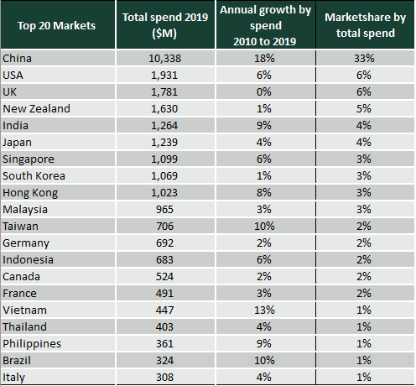 | Figure 2: Australia’s top 20 markets (by visits to Australia) 2010 to 2019 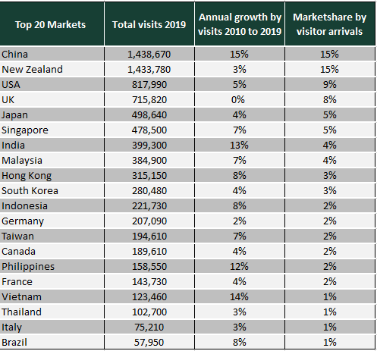
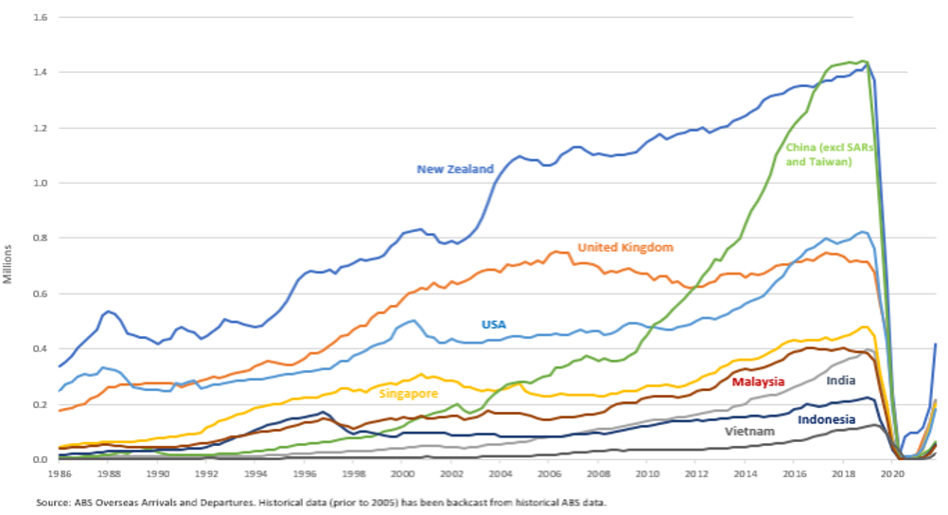
Figure 3: Short-term visitor arrivals in Australia by origin market, 1986-2022
Figure 4 demonstrates how the student market was a significant factor in an increasingly concentrated mix of visitors to Australia between 2010 and 2019, through a mathematical concept known as the Herfindahl Index: a higher number indicates higher market concentration and therefore lower diversity. Over this period Australia’s visitor economy market concentration score increased from 10 per cent to 16 per cent, with the majority of this change in concentration coming from the international education market. There have been much smaller increases in market concentration over the same period for other segments.
International students, their visiting friends and relatives and other edu-tourists make a significant contribution to Australia’s visitor economy with Tourism Research Australia (TRA) analysis showing the sector only increasing its importance and contribution towards the overall mix of visitors. In 2010, 29 per cent of international visitor spend in the Australian visitor economy came from international students. By 2019 this had grown to 39 per cent.
Figure 4: Herfindahl Index for Spend in Australia by Purpose of Visit, 2010 and 2019

Questions
- How would you assess your current level of market diversification?
- How important is market diversification for your business/organisation? Are you actively pursuing new opportunities to reduce market concentration and risk? What has worked well and not so well (case studies)?
- What steps have you taken to diversify into new or non-traditional markets?
- What emerging opportunities is your business/organisation interested in pursuing?

2. Context and trends

2.1 Post-pandemic visitor economy trends
As seen in Figure 5, China’s closed borders throughout 2022, combined with the slow recovery of traditional longer haul source markets such as North Asia, the UK, Europe and the US, saw total international arrivals for 2022 recovering to just 39 per cent of 2019 levels. Chinese government announcements in January 2023 regarding the removal of COVID-19 border restrictions and the requirement that international academic qualifications must be completed in-person have paved the way for a return of Chinese visitors.
Recent figures for January and February 2023 show some encouraging signs of increasing demand and recovery, particularly from within the Indo-Pacific region and in western markets where Tourism Australia and Study Australia marketing has increased. While Singapore and India were the quickest to recover in 2022 and are now prominent amongst Australia’s top 5 largest source markets, shorter-haul destinations such as Indonesia, Philippines and Vietnam have nearly fully recovered to 2019 levels, helped by increases in direct aviation to service the strong Australian outbound, student and VFR markets. Northeast Asian markets continue to recover at a slower rate with border reopening, air capacity, pricing and workforce constraints hampering recovery.
Trends towards shorter-haul, in-region travel in the recovery period may be explained by a range of reasons including health and safety considerations (people are still choosing to holiday close to home while the pandemic continues) and the increased cost of long-haul airfares. Travellers are also increasingly aware of their carbon footprint, which will be an important issue for long-haul destinations such as Australia to address to remain competitive as a destination in the future.
If traditional long-haul markets in North Asia, North America and Europe fail to fully recovery due to the high cost of airfares, a change in travel preferences, or in response to weakening economic conditions, an increased focus on emerging markets will be important to help the Australian visitor economy recover sustainably and develop resilience. Developing and growing new source markets of travellers to Australia will also be important over the medium to long term.
TRA analysis, as seen in Figure 7, shows that the gradual recovery of international visitation since the reopening of borders was initially led by those visiting friends and relatives, with most major markets which usually favour ‘holiday’ as the key purpose heavily skewed towards VFR in the post-pandemic recovery period. Taking the US market as an example, in June 2022, 55 per cent of the market was VFR and 24 per cent holiday, compared to 30 per cent VFR and 46 per cent holiday in June 2019. However, as international travel continues to resume, additional capacity is added and flight costs begin to stabilise, the holiday segment has bounced back. January 2023 was the first month since reopening that the number of arrivals visiting Australia for a Holiday outnumbered VFR.

Figure 5: Short-term (less than one year) visitor arrivals, selected markets
Market | Total 2019 | Total 2022 | % Recovery | Jan-Feb 2019 | Jan-Feb 2023 | % Recovery
New Zealand | 1,433,770 | 697,630 | 49% | 184,960 | 144,130 | 78%
UK | 715,820 | 399,190 | 56% | 159,320 | 127,180 | 80%
USA | 817,990 | 326,030 | 40% | 151,850 | 119,400 | 79%
India | 399,300 | 303,330 | 76% | 57,080 | 51,130 | 90%
Singapore | 478,500 | 295,800 | 62% | 50,470 | 30,810 | 61%
Indonesia | 221,730 | 90,840 | 41% | 25,370 | 21,280 | 84%
China | 1,438,670 | 89,250 | 6% | 349,130 | 55,060 | 16%
Canada | 189,610 | 88,010 | 46% | 42,870 | 30,520 | 71%
Germany | 207,090 | 85,350 | 41% | 44,920 | 30,340 | 68%
Malaysia | 384,900 | 85,260 | 22% | 41,930 | 20,420 | 49%
Philippines | 158,550 | 80,290 | 51% | 20,370 | 19,240 | 94%
Japan | 498,640 | 79,390 | 16% | 75,740 | 33,480 | 44%
S. Korea | 280,480 | 72,510 | 26% | 60,700 | 43,250 | 71%
Vietnam | 123,460 | 69,820 | 57% | 20,800 | 20,210 | 97%
France | 143,730 | 60,520 | 42% | 28,410 | 18,320 | 64%
Hong Kong | 315,150 | 53,720 | 17% | 51,670 | 22,550 | 44%
Italy | 75,210 | 36,320 | 48% | 13,420 | 9,390 | 70%
Brazil | 57,950 | 29,400 | 51% | 10,670 | 7,340 | 69%
Taiwan | 194,610 | 26,160 | 13% | 37,000 | 18,280 | 49%
Total SE Asia | 1,509,970 | 696,280 | 46% | 175,780 | 127,930 | 73%
Total NE Asia | 2,743,500 | 326,460 | 12% | 576,710 | 174,750 | 30%
Total all | 9,465,900 | 3,694,360 | 39% | 1,658,370 | 1,013,120 | 61%
Figure 6: International visitor arrivals for selected markets by month – Oct 2021 – Feb 2023
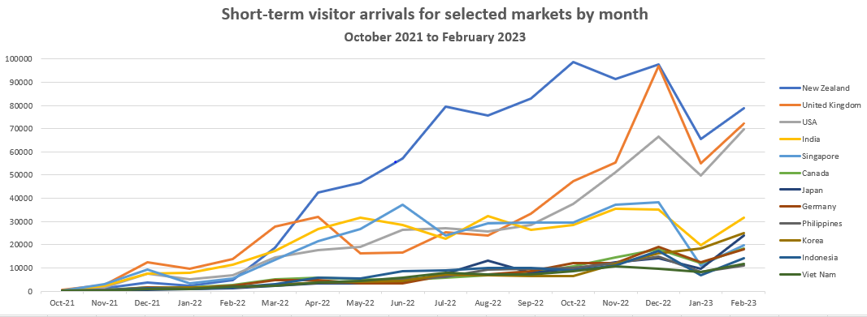

Figure 7: Short term visitor arrivals by purpose for visit and month
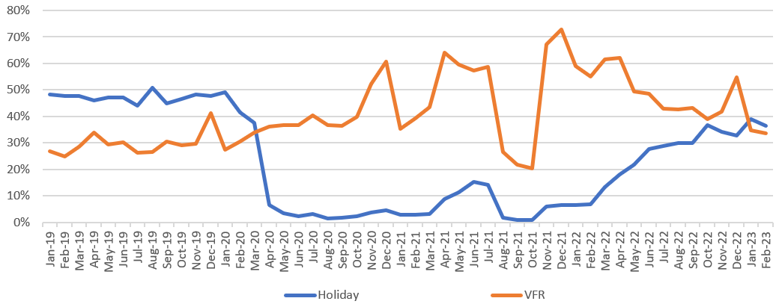
Questions
- What trends in international travel do you see impacting upon Australia’s source markets for visitation, and how are you responding?
- What intelligence and data do you have with respect to whether the current trends immediately post-COVID will continue or change?
- How have you changed, or are you planning to change, your product offerings and marketing to adjust to the post-COVID environment?

2.2 Supporting diversification of the visitor economy
Prioritising markets in which to allocate finite government and industry resources towards marketing, supply-side industry development and government-to-government bilateral cooperation initiatives is a complex process that involves multiple stakeholders and businesses and considers wider government priorities, along with the geopolitical and economic environment. Adjusting priority markets is also part of the natural cycle of the tourism industry and will inherently be industry-led and consumer-driven.
The process of diversifying into new markets requires a sustained, long-term commitment and investment from governments and industry. It can benefit from several aspects, including but not limited to:
- Research and analysis of traveller activity and intentions;
- Strong bilateral government to government cooperation to address barriers to two-way visitation;
- Support to industry to build relationships and supply chains, including export assistance programs such as those provided by Austrade;
- Investment in industry development and capability, including technology and staff development, to improve cultural and linguistic skills, develop greater understanding of First Nations and gender equity issues, and improve the industry’s readiness to service diverse markets;
- Investment in new products and experiences that are culturally appealing, relevant, accessible and inclusive. This includes access to expansion capital and improved facilities and signage;
- Aviation route establishment (a mix of commercial factors and State Government investment);
- Business decisions made by tourism operators and enabling factors such as dissemination of market insights;
- Access to risk management products (e.g. insurance and syndicated loans);
- Australia’s nation brand being suitable for use in a broader range of markets;
- Government and industry marketing investment via Tourism Australia (for leisure and business travellers) and Austrade (for international education); and
- Supportive marketing investments made by State and Territory Governments and industry.

2.3 What is the Government already doing to support diversification in the visitor economy?
Austrade provides policy advice to government, delivers a range of programs to industry and is the lead agency for implementation of the THRIVE 2030 strategy for the visitor economy. Trade diversification is a key priority for Australia which Austrade is delivering across other market sectors.
In its work on the Visitor Economy, Austrade engages in market diversification by liaising closely with DFAT, Department of Education, the Department of Home Affairs and the Department of Infrastructure, Transport, Regional Development and Communications on international tourism and international education issues such as visas, workforce, industry capability, leveraging international bilateral agreements to increase access and cooperation to grow people to people links, and showcasing Australia’s tourism and international education policy and industry success stories in bilateral and multilateral fora such as the OECD, G20 and APEC.
Tourism Australia (TA) is the Australian Government agency responsible for attracting international visitors to Australia, both for leisure and business events. TA concentrates its international tourism marketing efforts on 15 strategically chosen countries, with a focus on their designated high yielding “grow” markets of the UK, US, China, Japan and Singapore. TA selected these priority markets based on several historic and future factors such as past performance; balance between East and West; maturity of consumer (general awareness of Australia); cultural ties; aviation access; future growth potential; Australian industry appetite and interest (noting different State and Territory preferences for different markets).
TA’s purpose is to ‘grow demand enabling a competitive and sustainable tourism industry’ – on the demand side this means motivating the worlds’ travellers to choose Australia over the many other excellent destinations available to them. TA annually reappraises the markets where it invests its budget with a view to driving incremental growth over time. TA’s 15 ‘core markets’ include China / HK, Japan, South Korea, USA, Canada, UK, Germany, Italy, France, Singapore, Malaysia, Indonesia, and New Zealand. ‘Grow’ markets are selected from that suite depending on whether TA’s budget can realistically generate an increase in market share over the mid-term. To drive share growth TA relies on brand advertising, commercial partnerships, industry marketplaces, and training distributors in Australia.
TA engages in market diversification through two mechanisms: (i) providing trade platforms and market insights that enable Australian tourism businesses to make informed decisions and then enter a diverse range of tourism markets; and (ii) by undertaking marketing in a balanced portfolio of 15 markets.
To assist operators in growth markets, each year TA hosts the Australian Tourism Exchange (ATE), a large trade event that provides a platform for Australian businesses to meet and explore business relationships with tourism wholesalers and agents from around the world. This is a key avenue for tourism businesses to enter new markets.
Entering new markets is a significant undertaking for TA. There are lead times associated with market establishment and delivery of complementary measures, including industry development, aviation capacity and air service rights, and competitive visa access arrangements, by industry and a range of government agencies is also important to ensuring success with this marketing investment.

Come and Say G’day is the next instalment of Tourism Australia’s There’s Nothing Like Australia global brand platform. The multi-channel campaign introduces the world to two lovable CGI animated characters; Ruby, a souvenir kangaroo, voiced by Australian actor Rose Byrne, and Louie, a toy unicorn, representing international visitors, voiced by actor Will Arnett.
The Come and Say G’day campaign is running across Tourism Australia’s 15 key international markets from October 2022 and aims to support the tourism industry’s recovery by driving demand for travel to Australia.

3. Barriers to growing new markets
As the world recovers from the pandemic and adjusts to new travel patterns, there are opportunities to capture market share in new international markets and build sector resilience. However, there are challenges in growing new markets which may take time to overcome. Operators continue to experience workforce constraints due to many key staff having left the industry. Businesses are working hard to train new staff and service the current high demand from domestic and traditional international markets, which could constrain the allocation of resources necessary to explore and invest in new emerging markets. Identifying how governments and industry can work together to overcome barriers and assist businesses to build markets will be a key component of a diversification strategy.
Barriers to industry accessing new markets could take several forms, ranging from financial capacity, market risk, aviation connections, capacity of the sector to service these new markets, as well as regulatory impediments. Initial consultations in preparing this paper, including direct feedback from the tourism export industry, have also raised visa competitiveness, workforce constraints and limited financial capital as key issues to address in the near-term to help grow new markets. Many tourism enterprises have had to redirect existing capital and savings to operating expenses or costs to pivot to domestic markets during COVID and may not have sufficient capital to diversify and build new product.
Austrade’s Export Market Development Grant (EMDG) Scheme is annually helping more than 8000 Australian small and medium enterprises (SMEs) start or expand their export business and has been used by tourism operators over recent years. The program has a fixed annual budget and is designed to build capacity in exporting rather than fund ongoing support. Some experienced operators have noted in initial consultations that they have exhausted or are close to using up their eight years of access to the EMDG program and that enabling additional support targeted towards specific markets would ensure they can play a role in diversification. The Government’s $10 million election commitment and October 2022 budget funded “Reviving International Travel” measure will provide some important assistance in the near-term.
Raising awareness of new opportunities and providing support to businesses who want to learn about, and access new markets will also be important. TA has also worked with Austrade and the Australian Tourism Export Council (ATEC) in developing industry development modules – such as the India and Indonesia host programs available in the new ATEC Tourism Training Hub – that specifically assist Australian industry to prepare for visitors from these markets. The Host Program is an example of an ‘industry led, government enabled’ initiative to help operators service new, culturally different markets.
As Australia re-opened its borders to international visitors, travellers experienced visa processing delays. Processing backlogs continue to be addressed with the Australian Government providing an additional $36.1 million for visa processing, to support a surge capacity of 500 staff to June 2023. Good progress is being made with positive signs from industry that staffing constraints are starting to ease as a result.
Another important consideration for a diversification strategy is that industry has access to the necessary cultural and linguistic skills to service new markets. This involves training as well as temporary and permanent migration solutions to help fill skill gaps. Following the recent Jobs and Skills Summit, the Australian Government increased the number of permanent migration visas available in 2022-23 from 160,000 to 195,000 places and has released for discussion a Migration Strategy, informed by a comprehensive review of Australia’s migration system.
Further, all States and Territories have included fee-free tourism and hospitality TAFE places, in their implementation of the Australian Government’s fee free TAFE election commitment. Across Australia, there are almost 14,000 tourism and hospitality TAFE places being offered fee-free, helping ensure we are developing the necessary skills required for success, assisting Australia to be competitive in the global race for talent and supporting a diversified range of markets.
Questions
- What immediate challenges does your business/organisation face in growing markets? Please rate financial capacity, market risk, access, workforce and regulatory impediments, in order of priority, adding any further information on barriers you see.
- What challenges do you anticipate in the medium-term (next 2-5 years) in growing new markets? Please rate your medium-term challenges as per the question above.
- Are you experiencing any workforce constraints in servicing international markets? If so, what specific staff or skills are you seeking that you are unable to find?

Cricket World Cup 2015 at Adelaide Oval, Adelaide, South Australia (Tourism Australia)

4. Market Analysis

4.1 Assessment of markets with diversification potential
As noted in the June 2021 report, Opportunities for the visitor economy, “Post-pandemic, the Visitor Economy should seek to achieve a well-balanced inbound market by nurturing its traditional sources (English-speaking and other Western markets) and doubling down on fast-growing Asian markets”.
To further explore the findings of this report, Austrade, in cooperation with Tourism Research Australia (TRA), has completed an initial quantitative research exercise, analysing a range of travel, economic and demographic indicators from 53 markets. For the purposes of this discussion paper, international students, regardless of their length of stay, are included in this analysis, reflecting their statistical likelihood to behave more like visitors rather than residents.
The objective of this market analysis project was to identify a range of international markets with ‘diversification potential’, meaning markets that show potential to grow beyond current levels.
As noted in Section 1.3, while businesses will ultimately make their own decisions on the markets that they want to engage with, different strategies at both the industry and government levels will need to be considered to support the growth of different markets, depending on their characteristics and stage of maturity. The list below is therefore put forward to start a conversation with industry about potential markets of the future to help guide future policy and strategy.
A wide range of indicators in each market from Euromonitor, TRA and Study Australia data were analysed under six categories:
Visitor Economy: total outbound, Australian inbound, expenditure, yield, segments, student enrolments, competitors​.
Demographics: population, middle class, affluence, major cities​.
Economy: GDP, consumer confidence, inflation, internet access, political stability index.
Cultural: language, English proficiency, Australian diaspora, peak travel periods/cultural holidays​.
Air transport links: passengers, capacity, utilisation, direct routes and flight time​.
Bilateral relationship and trade: bilateral trade, agreements, and multilateral tourism membership.

4.2 International markets of interest
The diversification indicators project suggests 10 international markets of primary interest with diversification potential. Four of these (India, Vietnam, Indonesia and Malaysia) hold ‘strong potential’.
This is not to say existing traditional markets, such as the UK, USA and China, will not continue to be important to Australia into the future. The UK market, worth $1.78 billion to the Australian economy in 2019, will still demand attention to maintain and potentially grow market share.
The diversification markets of interest are listed below. Six of these are TA priority markets and have extensive country profiles on the TA Website. Austrade also makes information about education markets available through the Market Information Package.
Austrade is responsible for the international marketing and promotion of Australian education and training. Through its extensive international network, Austrade provides market intelligence and identifies quality opportunities in key markets. Information is disseminated to the Australian education sector to assist providers to make informed decisions and develop strategies to build international relationships and business. A key priority is the development of transnational education opportunities in growth and emerging markets, especially in Asia.
All the 10 individual markets of primary diversification potential (except the Philippines) are covered by the Working Holiday Maker Scheme (comprising the Working Holiday (subclass 417 visa) and the Work and Holiday (subclass 462) visa), with India due to be included in the near future, as announced by the Minister for Trade and Tourism.

STRONG POTENTIAL

India
The Indian market has been a strong performer in the post-COVID recovery period, being one of the first to rebound due to strong VFR demand. Capacity has been restored and new routes established, seeing total visits for 2022 recover to 76 per cent on 2019 levels, the highest recovery rate of all Australia’s top markets.
Between 2010 and 2019, the value of the India market grew at an annual average growth rate of 9 per cent to $1.264 billion, representing a 4 per cent share of total international visitor spend, making it our 5th largest source market by spend.
India is also Australia’s fastest growing education market. This has largely been driven by a surging middle class (India's middle class is set to grow rapidly from up to 80 million today to 580 million people – or about 41 per cent of the population – by 2025) and the fastest growing diaspora in Australia. In the 2021 Census, the number of people reporting Indian heritage was 976,000 or 3.8 per cent of the Australian population. Of these, there were 673,000 Indian-born Australians, representing 2.6 per cent of the Australian population.
Migration patterns will continue to have a significant impact on the VFR, business events and education segments, with the market having already rebounded strongly to near pre-pandemic levels and flight capacity, including new direct routes, being added to meet demand. Despite the strong growth being recorded, Australia has been losing market share by value. Between 2009 and 2019, total Indian outbound expenditure grew at 18.4 per cent annual average growth (from US$10 billion to $37.5 billion), while total spend in Australia grew below that with 10.3 per cent annual average growth ($476.2 million to $1.264 billion).
Growth in India is also supported by the India-Australia Economic Cooperation and Trade Agreement (I-A ECTA). Under this agreement, India has guaranteed Australian services suppliers in 31 sectors and subsectors, including tourism and travel, the equivalent to the best treatment accorded to its future FTA partners, meaning Australian suppliers will always receive India’s best available market access.
Further, within two years of the I-A ECTA entering into force, Australia will allow up to 1000 eligible Indian citizens per year to access the Work and Holiday (subclass 462) visa. This visa enables them to undertake short-term work and study while holidaying in Australia for one year.
India is currently the only country with which Australia has an active bilateral tourism agreement, following the renewal of the Australia-India Memorandum of Understanding on Tourism Cooperation in February 2022.

Vietnam
Vietnam shows great diversification potential in general and for our visitor economy. ​Data analysis shows that Vietnam had the highest growth in total outbound travel of all 53 markets and 2nd highest growth in total arrivals to Australia, albeit from a low base. Between 2009 and 2019, total outbound trips from Vietnam grew by 18.3 per cent. However, Australia’s share of total outbound travel reduced from 1.3 per cent in 2009 to 0.78 per cent in 2019, with many of our competitors actively targeting the rapidly expanding leisure segment. In 2019 there were 7.8 million Vietnamese trips to China, with 600,000 trips to Singapore, and 496,000 to Japan, but only 123,460 to Australia.
The strength of the Australian outbound sector has ensured extensive low and full-service direct access, with direct and one-stop flights as low as $300 as new entrants such as Jetstar, Viet Jet, Scoot and Bamboo provide aggressive price competition on the route. This provides a strong opportunity to grow the inbound market.
Vietnam has been a development success story, going from one of the world’s poorest nations to a middle-income economy in one generation. Between 2002 and 2021, GDP per capita increased 3.6 times, reaching almost US$3,700. This growth is due to a large consumer base, outward looking population, growing middle class and rising incomes. There were over 7.5 million middle class households in Vietnam in 2019.
Market potential is also supported by Australia’s strong bilateral relationship, with leaders recently announcing Australia and Vietnam’s shared intention to elevate the relationship to a Comprehensive Strategic Partnership.
Strong people to people links and VFR potential will be supported by the large Australian-Vietnamese diaspora, with the 2022 Census showing 257,997 Vietnamese born people living in Australia (194,285 of them Australian citizens), 320,758 people speaking Vietnamese at home and 31,876 student enrolments in 2019.
The Vietnam-Australia Enhanced Economic Engagement Strategy, agreed by respective Prime Ministers on 23 August 2019 and launched in November 2021, provided a subsequent framework for increased economic cooperation, with tourism noted as a key sector: ​
“Vietnam and Australia will cooperate to support two-way tourism to rebound and grow once it is safe to do so, including through supporting the development of a skilled tourism workforce to combat labour shortages as the sector begins to recover, with a particular focus on promoting women’s engagement and leadership in the sector.”​

Indonesia
Even before the disruption caused by COVID-19, Australia was seeing above-average growth in tourism from Indonesia. Between 2010 and 2019, spend in Australia by Indonesia travellers increased at an annual average rate of 6 per cent. By 2019, this saw them spend $683 million in Australia’s visitor economy and account for 2 per cent of international spend. There has been a strong increase in arrivals from 107,000 in 2009 to 221,000 in 2019 at 7.5 per cent annual average growth, mainly through the education and VFR market. However, Australia’s market share in 2019 was just under 1.9 per cent of a total 12 million outbound departures, with Malaysia being the preferred destination for Indonesians with 3.6 million departures, 2.5 million to Singapore and 310,000 arrivals to Germany.
Indonesia’s population will increase by 17.7 per cent between 2019 and 2040 and is forecast to reach 319 million in 2040, meaning Indonesia will continue to be the third largest country in the Asia Pacific region.
TA established an office in Jakarta in 2015 and maintains a presence there, concentrating its activity within Jakarta, with more limited reach in the islands beyond Java. While Australia has a high appeal, knowledge of Australian destinations and experiences amongst most Indonesian travel agents remains low and access to information in Indonesian language (such as availability of Halal food) can be difficult to obtain. Consultations have also noted a large amount of market substitution with travellers choosing alternative destinations due to difficulties in obtaining Australian visas. There appears to be strong diversification potential in the medium to longer term with an increased focus on supply-side issues, such as industry capability development and visa competitiveness.
Growth in Indonesia is also supported by the Indonesia-Australia Comprehensive Economic Partnership Agreement. This agreement provides better and more certain access to the Indonesian market for goods, services, and investment including benefits for Australians looking to invest in Indonesia’s tourism industry.

Malaysia
Malaysia is an interesting market which Australia has performed relatively well in by growth in visits, although it has been underperforming by growth in expenditure, suggesting that there is potential to capture more growth from the higher value traveller. Between 2009 and 2019, total visits grew at an annual average growth rate of 6.5 per cent to 384,900 arrivals, above the 5.4 per cent average annual growth in total outbound over the same period, seeing our market share by visits growing from 1.9 per cent to 2.2 per cent. However, over the same period, expenditure in Australia grew at an annual average growth rate of just 3.4 per cent (from $688 million in 2009 to $964 million in 2019), well below the 7.8 per cent annual average growth in total outbound expenditure over the same period. The relatively low levels of yield per trip ($1,580 per holiday trip and $1,707 per VFR trip) despite the high spend per day ($208 per day per holiday trip) further suggests growth potential from increasing Malaysian visitors’ length of stay.
Malaysia’s population is expected to grow at a high rate of 8.8 per cent to 37.8 million by 2040, with its economy also on an upward trajectory, averaging growth of 5.4 per cent since 2010, and is expected to achieve its transition from an upper middle-income economy to a high-income economy by 2024. With Malaysia’s growing economy, extensive access from low-cost and full-service airlines and strong people to people links, continued growth is forecast. Many Malaysians travel within region, with Singapore, Thailand and Indonesia all receiving 3 million or more Malaysian visitors in 2019.
This market is also supported by a strong bilateral trade relationship between Australia and Malaysia, which reached a significant milestone with the signing of the Malaysia-Australia Free Trade Agreement (MAFTA) in 2012. Under this arrangement, Australian investors are guaranteed the right to majority ownership in companies in a wide range of sectors supplying services in Malaysia, including tourism.

GOOD POTENTIAL

USA
The USA has been a strong tourism performer for Australia for many decades, growing 6 per cent between 2010-2019. The USA market is worth $1.9 billion to Australia and accounts for 6 per cent of international spend. With good point-to-point access, advances in long range aircraft opening new direct destinations and a strong TA presence in market – there is strong potential for continued growth, particularly with regard to high yield leisure and business traffic. The USA is not a priority market for Study Australia; however, the edu-tourism market may present further niche opportunities.
Significant opportunities may also be present in the American accessible tourism market, with a 2015 study suggesting the market was worth around $17.3 billion annually, with a more recent study showing that travellers with disability in the US reported an average spend of US$500 more on leisure travel, compared to those without disability.

Singapore
Singapore has been a strong market for Australia, with expenditure growing at an annual average growth rate of 6.2 per cent from $600 million in 2010 to over $1 billion in 2019, accounting for 3 per cent of total international visitor economy spend in Australia. Backed by a strong TA presence, extensive point-to-point access, and established bilateral relationships, the market has recovered strongly in 2022, with arrivals at 62 per cent on 2019 numbers, the second highest recovery rate of all markets. Increasing demand for Australian high-end products and experiences can be expected from Singapore’s large and rapidly growing pool of ultra-high net worth individuals.

Taiwan
With only limited investment in marketing from Study Australia and state tourism organisations, Taiwan grew strongly in the decade prior to the pandemic with an above average 10 per cent year on year growth to be worth over $700 million to the Australian economy in 2019, our 11th biggest market. Prior to the imposition of restrictions on international travel, in 2019 there were 194,610 short-term visitor arrivals from Taiwan and 18,513 students from Taiwan enrolled to study in Australia.
The market is forecast to rebound strongly, with total outbound trips forecast to grow to 23.4 million by 2026 (up from 19.4 million in 2019). Strong indicators of growth are driven by the large consumer base, high incomes and stable economy contributing to good potential for high yield visitors, for example leisure travellers spent $3,310 per trip in 2019 (ranked 6th highest yielding market)​.
Taiwan’s population peaked at around 23.6 million in 2019 and is forecast to decline due to a low birth rate. Although the population will begin to decrease, Taiwan should become a progressively more attractive consumer market as incomes rise further, remaining significantly higher than the regional average on a per capita basis. Taiwan and Australia share a wide range of people-to-people links developed through business and tourism-related travel, academic exchanges, family ties and Australia’s Working Holiday Maker Scheme. Australia is Taiwan’s second-most popular education destination and the most popular destination for Taiwanese Working Holiday Makers (in 2019, 63.3% of all Taiwanese WHMs chose Australia).

Philippines
The Philippines shows strong annual growth driven by students, strong access, and VFR links, although visitors are typically lower yielding in terms of spend​. Strong growth in travel from this market is driven by a surging economy and population, fast rising middle class and rising affluence. By 2018, the middle class had expanded to nearly 12 million people and the economically secure population had risen to 44 million.
The Philippines and Australia have a strong bilateral relationship underpinned by the Joint Declaration on Australia-The Philippines Comprehensive Partnership.​ This is also evidenced by Australia's total two-way goods and services trade with the Philippines, which was $5.6 billion in 2019, making the Philippines our 19th largest trading partner​. At the end of June 2019, 293,770 Filipino-born people were living in Australia, 67.8 per cent more than the number (175,020) on 30 June 2009. This is the fifth largest migrant community in Australia.

Thailand
Between 2009 and 2019, the value of the Thailand market grew at an annual average growth rate of 9 per cent to US$12 billion, with total expenditure in Australia growing from $287.9 million to
$402.7 million (3.4 per cent annual average growth). Australia has also seen a 3.4 per cent increase in arrivals from 73,000 in 2009 to 102,000 in 2019, helped by a strong student sector with 26,168 student enrolments in 2019. With Thailand’s economy forecast to expand at a compound annual growth rate of 2.8 per cent over 2022-2040, extensive direct access, a growing population and rising affluence (GDP nearly doubled between 2009 and 2019), underpinned by bilateral and multilateral free trade agreements, strong diasporas and AustCham links, this market presents good long-term diversification potential.

Brazil
Between 2009 and 2019, the value of the Brazil outbound travel market grew at an annual average growth rate of 4.7 per cent to around US$28 billion, with total expenditure in Australia growing from $131.2 million to $324.4 million (9.5 per cent annual average growth). Australia has also seen an 8 per cent increase in arrivals from 26,900 in 2009 to 57,900 in 2019. Arrivals have doubled since 2009, largely due to strong growth in student enrolments growing to 40,918 in 2019. Brazil’s population is forecast to grow by 8.4 per cent per year to 229 million in 2040, remaining the largest country in Latin America. Access remains an issue for this market. A direct air service could present new opportunities beyond the student segment.
From 1 July 2022, up to 500 eligible Brazilian citizens per year, have been able to access the Work and Holiday (subclass 462) visa, enabling them to undertake short-term work and study while holidaying in Australia for one year.
Questions
- Which international markets do you see as important to grow for your business or organisation?
- Do you have any further insights to support future strategies in growing either traditional or emerging markets?

Halal Dining at Zaaffran Restaurant, Darling Harbour, Sydney, NSW (Tourism Australia)

5. Market segments
Diversification is not only about countries but also about market segments that both cater for and attract current, new and emerging markets. The development of an International Diversification Strategy, under THRIVE Action Item 6.3, will also look at attracting certain growing (and higher yield) traveller cohorts including people seeking luxury, nature and cultural experiences.
Growing visitor segments is not only important to servicing Australia’s domestic market, but also attracting new and repeat international visitors. TA’s Future of Demand research and initial consultations in preparing this consultation paper, including feedback received directly from the tourism export industry, have raised opportunities to expand visitor segments in areas of accessible travel; First Nations cultural experiences; sustainable travel; events and LGBTQIA+ tourism.

Accessible travel
Around one in four travellers have some form of accessibility need when travelling. This includes people with physical impairments and those with any mobility, visual, audio or cognitive impairment. According to research by Travability, in 2017, domestic and international visitation by people with disability contributed $10.8 billion to the Australian economy.
By 2025, one in eight international trips will be taken by a retiree aged 60 or above. The size of that market will almost double in the coming decade, as the global ageing population grows by 40 per cent to 1.4 billion by 2030, with an increasing propensity to spend their retirement on travel.
The growing cohort of older travellers, multi-generational families, and people with disabilities means there must be a focus on accessible infrastructure, quality experiences, and a safe environment. TA’s Global Future of Tourism Demand research found that travellers with accessibility needs tend to go for longer holidays than those without accessibility needs and also have more travellers in their party, hence contributing more dollars to the visitor economy. Australia’s quality infrastructure and reputation for safe and secure travel positions us well to adapt to and attract these growing markets. THRIVE 2030 calls on industry to further develop and promote assets, infrastructure and experiences that are accessible to all people.

First Nations cultural experiences
There is a growing desire to engage more and learn from authentic cultural and First Nations experiences. Increasing awareness and growing Aboriginal and Torres Strait Islander experiences and products provides both domestic and international visitors greater opportunities to experience Indigenous cultures and will also help to increase visitor numbers to regions. It will also help promote and grow the unique offering of First Nations tourism businesses, help create new indigenous employment opportunities, allowing young people to locate themselves where they can remain connected to kin and culture.
TA’s Global Future of Tourism Demand research found markets with a strong interest in First Nations experiences include India, Indonesia, Philippines, Thailand, and Vietnam in addition to traditional markets of China and the UK. THRIVE 2030 is focused on growing First Nations experiences and products, with Austrade working closely with the National Indigenous Australians Agency, and a range of other government agencies and First Nations representatives, to support the First Nations visitor economy sector.

Sustainable tourism
The proportion of holiday and business travellers who prioritise ‘sustainable practices’ is rising noticeably. TA’s Future of Demand research notes that more than 75 per cent of travellers are now committed to sustainability in some way, with as many as half of all travellers from Southeast Asian markets such as Thailand and the Philippines being sustainability-conscious travellers.
The environmental impact of tourism is significant, accounting for 8 per cent of global carbon emissions in 2019. The visitor economy therefore has a part to play in reducing emissions and achieving national and global carbon reduction targets. Australia’s location as a long-haul destination for many existing markets also points to the importance of diversifying to closer markets in region that will result in less carbon impactful travel. To attract the environmentally conscious international traveller and grow consumer demand for sustainable tourism experiences, governments and industry must embrace leading edge business practices to create competitive, resilient, and sustainable businesses. This will also increase business efficiencies and reduce environmental impacts.
THRIVE 2030, is a strategy for growing sustainably – and recognises that Australia’s environment and culture are central to our attractiveness to visitors. THRIVE 2030 is driving a balanced approach to growth that weighs up economic, social and environmental issues in order to sustain a positive visitor experience and remain internationally competitive. Operators will need adapt by implementing and continually improving their sustainability practices.

Events
Sporting, cultural and business events are all very effective at driving high yield and high revenue visitation. In 2019, these trips drove over 10 million visitor trips, adding $5 billion to Australia’s visitor economy. Events are a critical part of our product portfolio and can play an important role in driving both domestic and international visitation, repeat visitation and dispersal into regional areas.
Coordination and collaboration are particularly important over the Green and Gold Decade of major sporting events, culminating in the Brisbane 2032 Olympics and Paralympics, which provides industry with significant opportunities to leverage the expected benefits of increased visitation.

LGBTQIA+ tourism
Opportunities may exist for businesses to target a more diverse of range of visitors by offering positive experiences to people with different needs and creating an environment where all people feel welcomed and safe. Australia’s diverse demographics, friendly culture, strong anti-discrimination laws and vibrant festivals such as Sydney Mardi Gras and the recent WorldPride event make it an ideal place to visit for LGBTQIA+ travellers, allies, friends and families.
LGBTQIA+ travellers can often face challenges and discrimination when travelling, which may cause hesitation when booking a trip or experience. Being aware of these challenges and recognising the types of products these travellers are searching for can assist visitor economy businesses customise experiences that appeal to a more diverse market. Industry-led initiatives such as Gay and Lesbian Tourism Australia provide a portal for industry to actively target this sector.
Questions
- What changes are you seeing in terms of traveller interests and how are you adjusting your products and experiences accordingly?
- What traveller market segments do you see as having the greatest potential to grow?

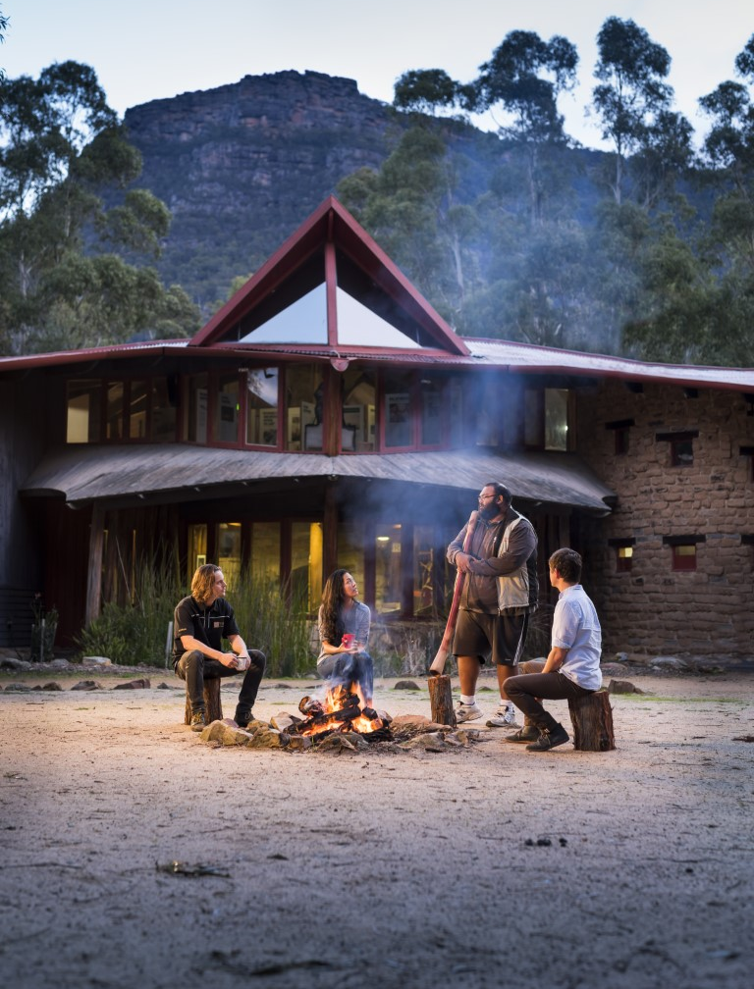
Brambuk National Park and Cultural Centre, Halls Gap, Victoria (Visit Victoria)
Austrade welcomes your feedback on this Discussion Paper. An easy and fast way to engage is through the Visitor Economy Diversification Stakeholder Consultation Survey, available here. Written submissions are also welcome, by 13 July 2023.

Edu-tourism and the impact of international students - IEAA (broadenourhorizons.com.au)
Tourism Research Australia, 2022, based on Oxford Economics data
China Travel Advice & Safety | Smartraveller
Great shortfall of China: Australia's biggest tourism market returns with a whimper | Reuters
Opportunities for the Visitor Economy, Austrade, page 50.
Overseas Arrivals and Departures, Australia, February 2023 | Australian Bureau of Statistics (abs.gov.au)
Tourism Research Australia analysis, based on ABS Overseas Arrivals and Departures data
Australia's Nation Brand (brandaustralia.com)
Market Regions - Corporate - Tourism Australia
Austrade has conducted an operational review of the EMDG program, for the Government’s consideration and response. Medium-term issues to reform EMDG will be considered as part of a consultation exercise prior to Round 4 and any longer-term EMDG policy issues that require significant change will be considered for the next legislative review due in 2026.
Visa backlog slashed in time for Christmas (homeaffairs.gov.au)
Tourism Australia Essentials Update 22 February 2023 (australia.com)
The Migration Strategy (homeaffairs.gov.au)
A Migration System for Australia’s Future (homeaffairs.gov.au)
Opportunities for the visitor economy, 2021 (austrade.gov.au)
Austrade (through Study Australia) is responsible for the international marketing and promotion of Australian education with a key priority being the development of educational opportunities in growth and emerging markets. The Department of Education is responsible for policy oversight of international education.
Trade deal with India delivers from 29 December | Minister for Trade and Tourism (trademinister.gov.au)
India's rapid rise and growing middle class creates hunger for commodities (afr.com)
Euromonitor
Euromonitor. Affluent adults - Number of adults aged 18+ with net wealth above US$1 million but below US$5 million.
Strengthening Australia's relationship with Vietnam | Prime Minister of Australia (pm.gov.au)
Australia – Vietnam Enhanced Economic Engagement Strategy Implementation Plan, Tourism chapter (dfat.gov.au)
Annual average growth rate, or compound annual growth rate (CAGR) is the annualised average rate of growth over a specified period of time longer than one year.
Overview: The World Bank in Malaysia (worldbank.org)
Malaysia-Australia Free Trade Agreement (MAFTA) - Austrade
New Nationwide Research on Disabled Travel Market from Open Doors Organization, USA (accessibletourism.org)
Insights from the Groundbreaking Portrait of Travelers with Disabilities Study – (Wheelchairtravel.org)
Singapore’s Ultra-Wealthy Population Will Likely Grow by About 300 Per Cent by 2026, (Tatler Asia)
The Future of Demand research covers 143 experiences across 20 markets and four target audiences: the High Yielding Traveller, Premium, Working Holiday Makers, and a more generic Long Stay audience.
Tourism Australia Global Future of Tourism Demand Research, 2022, page 115.
Travability, Understanding the opportunity for Australia in Accessible Tourism, 2018, page 4.
Opportunities for the Visitor Economy, 2021, page 41.
Tourism Australia Global Future of Tourism Demand Research, 2022, page 118; and Travability, Understanding the opportunity for Australia in Accessible Tourism, 2018, page 4.
Opportunities for the Visitor Economy report - Austrade, 2021, page 42.
THRIVE 2030.
TOURISM AUSTRALIA GLOBAL FUTURE OF TOURISM DEMAND RESEARCH, 2022, Page 113.
Ibid. Pages XII and 99.
Opportunities for the Visitor Economy, 2021.
Visit Gay Australia | Gay and Lesbian Tourism Australia

